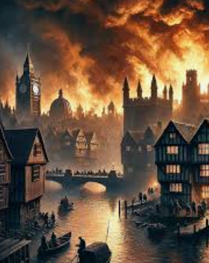
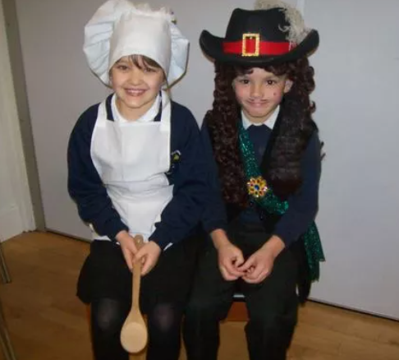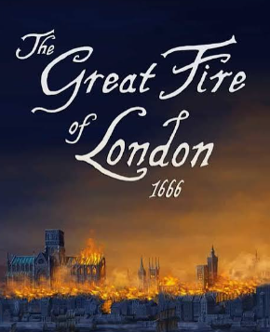
Dear Parents and Carers,
Our Enquiry Question for the Autumn Term is ‘What can we learn from the Great Fire of London and Gunpowder Plot?’
As part of our learning, we have invited Partake Theatre Company into school. Years 1, 2 and 3 will take part in an interactive school-based drama and history workshop focused on The Great Fire of London. We are looking forward to dressing up and meeting King Charles II, the baker Thomas Farriner and the famous diarist, Samuel Pepys!
Please can your child come to school in their uniform on the day of Partake’s visit. The cost of the visit will be a voluntary contribution of £6.30 per child. Please pay via SchoolMoney, as soon as possible.

Kind Regards,
Mrs Smith, Mrs Clark and Mrs Carrington.

