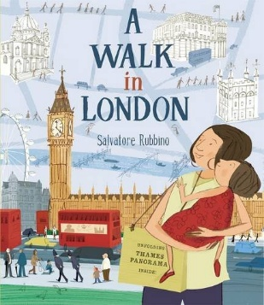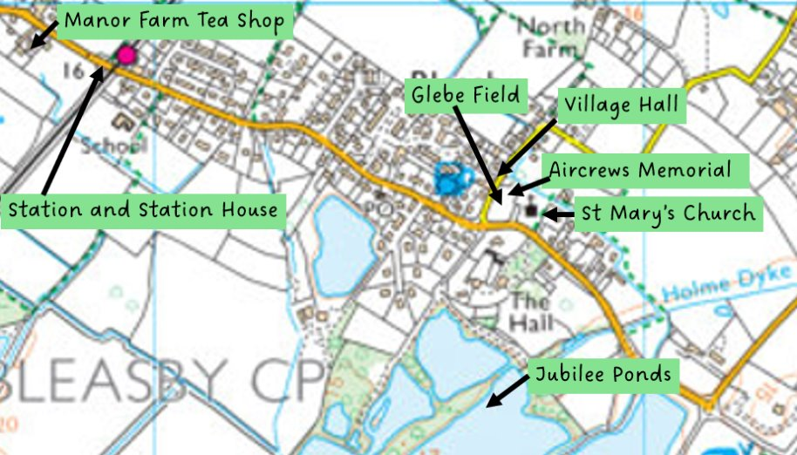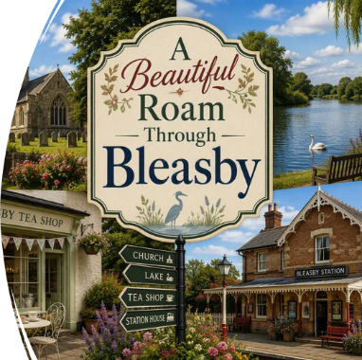
Dear Parents and Carers,
As you will be aware, this half term we have been working with the text ‘A Walk in London’ by Salvatore Rubbino. This work has led us onto researching local landmarks and writing a guide for ‘A Walk in Bleasby’. In Enquiry Geography, we have been looking at maps and photos and finding out about the natural and man-made features of landscapes.
On Wednesday 7th October, we will be heading off on a 2-hour stroll, to explore our village and see the places and landmarks we have described and studied.
Please can you send your child to school in sturdy shoes or trainers, wearing a light waterproof coat and a small carton / container of drink and a snack that will fit in a pocket. It is ok to bring juice, but you may prefer to send them with water. Suitable snacks would be a plain biscuit (wrapped, no chocolate) or small apple. Please note, the adults on the visit will not be able to carry drinks or snacks for your child.
The walk has been risk assessed in line with our local visits policy and we have plenty of adult helpers coming with us. As this is a short local visit, we are not asking for a consent to be signed, however, should you wish to discuss anything further, please contact Mrs Smith or Mrs Carrington.
Many thanks for your co-operation. We a looking forward to a lovely morning consolidating our learning.
Best wishes,
Mrs Smith, Mrs Carrington and Mrs Clark

