a
Silver Birch Class Information w.c. 20.7.26
English:   | English:  This week, the children will be continuing with the story of Tutankhamun. They will be writing their own biographies based on the discovery of Tutankhamun.
Maths:  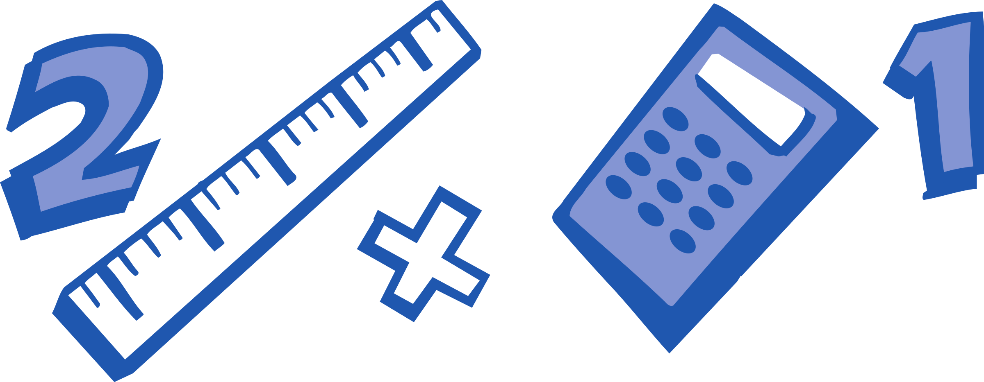 | Y2: Consolidation  This week, the children will be consolidating the maths they have been learning throughout the year.  Y3: Position & Direction  This week, the children will be describing the position of coordinates, plotting coordinates and translating coordinates.
Enquiry:  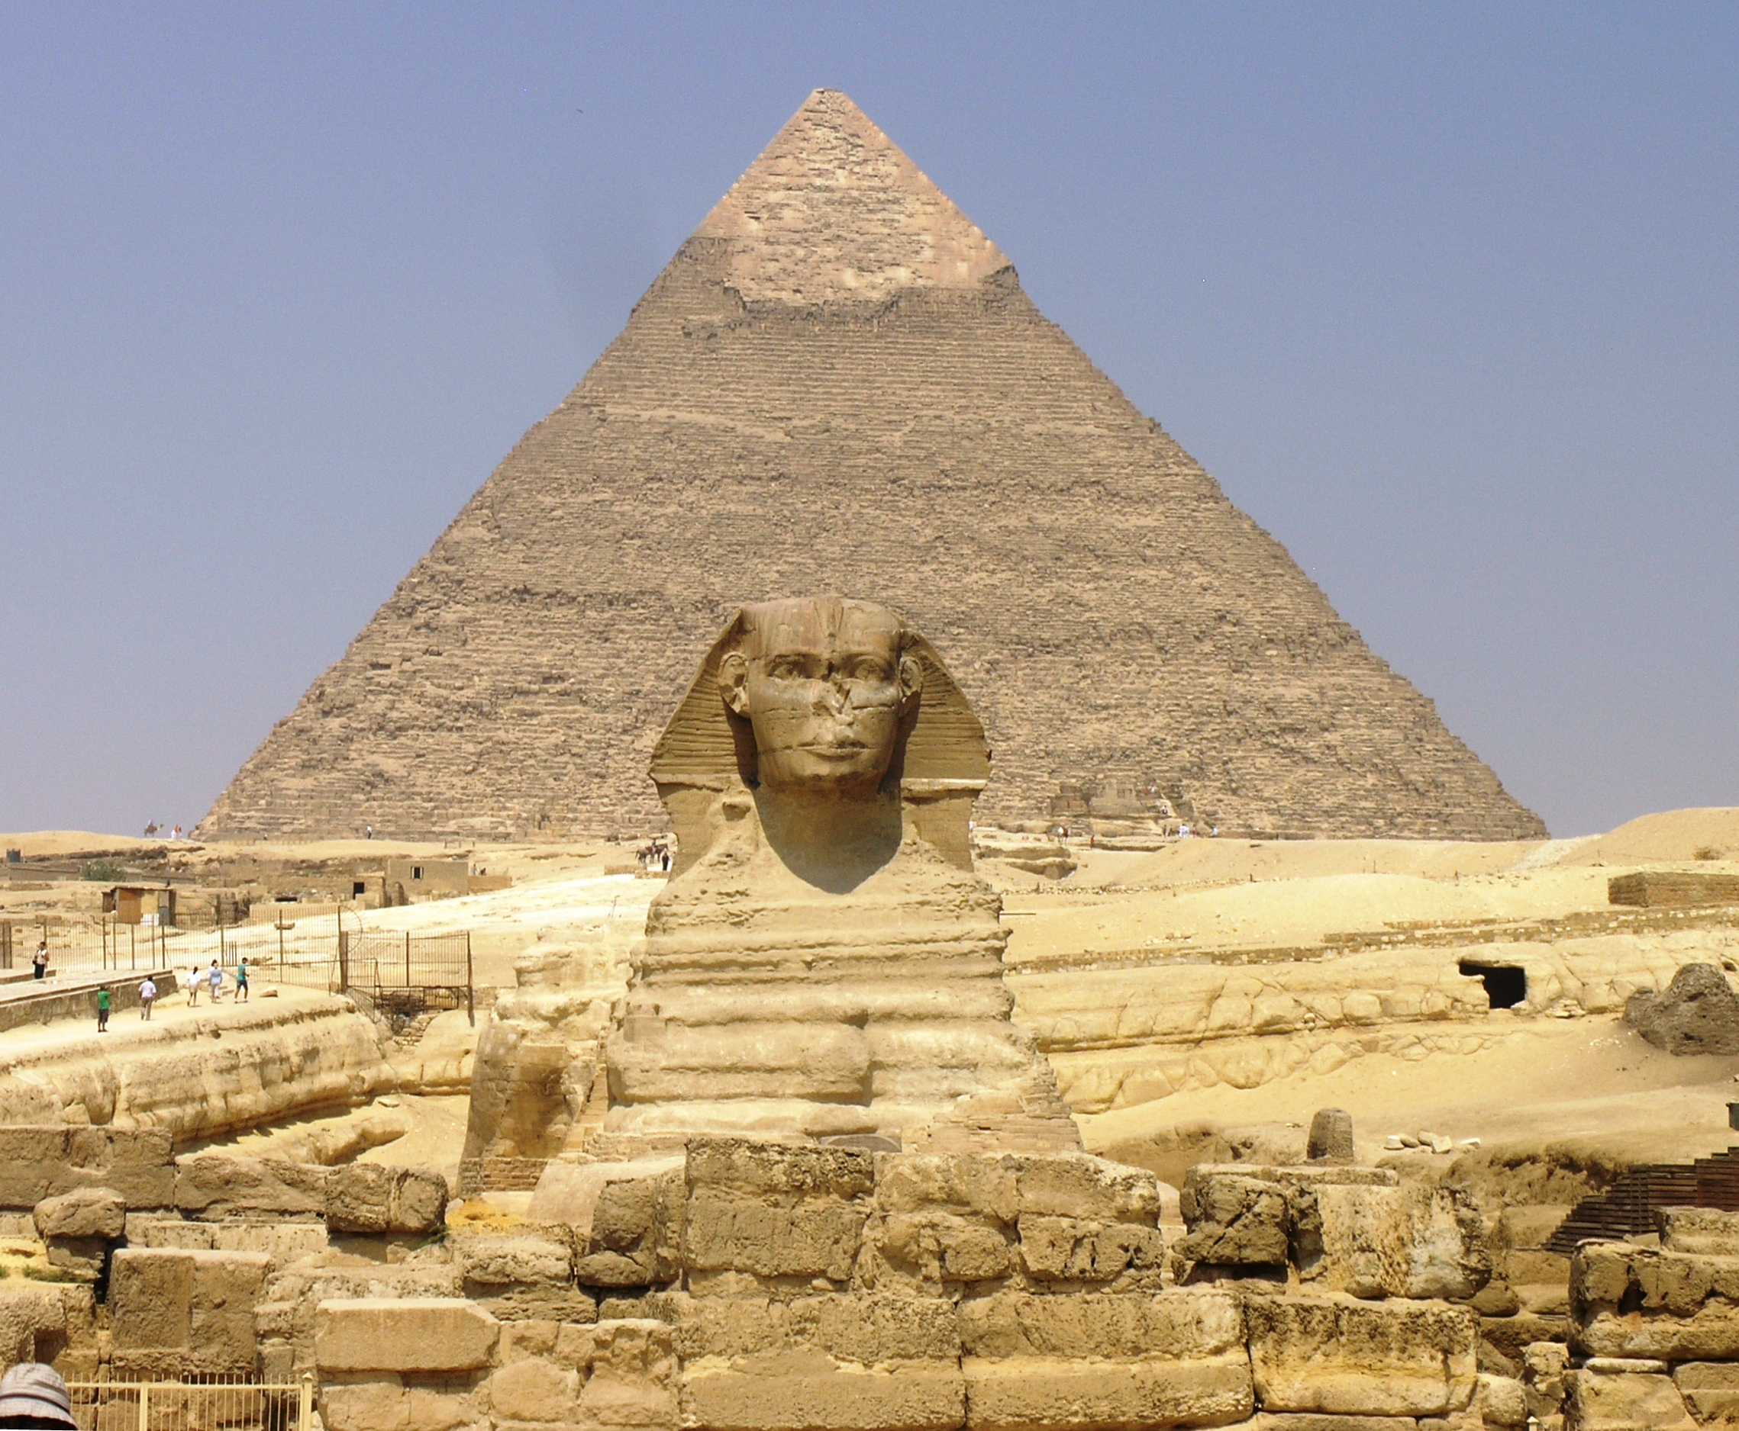 | Would you have wanted to have been an Ancient Egyptian?  This week, we will be sharing what we have found out about the Ancient Egyptians and answering our enquiry question.
ART/DT:   | Ancient Egyptian:  This week, the children will be creating their own Ancient Egyptian sarcophagus, based on our enquiry work about King Tutankhamun.
 | Messages:  Please bring a bag to collect school books and belongings on Wednesday. The children have won their class prize by filling their jar of marbles – their choice is to bring a toy into school on Friday afternoon and have non-uniform for the day as well.  I’d like to thank all the children and families of Silver Birch class for a fantastic year. I will miss being a part of this wonderful school. Enjoy the summer break!  Kind regards,  Mr Ryan

Silver Birch Class Information w.c. 20.7.26
English: | English:  This week, the children will be continuing with the story of Tutankhamun. They will be writing their own biographies based on the discovery of Tutankhamun.
Maths: | Y2: Consolidation  This week, the children will be consolidating the maths they have been learning throughout the year.  Y3: Position & Direction  This week, the children will be describing the position of coordinates, plotting coordinates and translating coordinates.
Enquiry: | Would you have wanted to have been an Ancient Egyptian?  This week, we will be sharing what we have found out about the Ancient Egyptians and answering our enquiry question.
ART/DT: | Ancient Egyptian:  This week, the children will be creating their own Ancient Egyptian sarcophagus, based on our enquiry work about King Tutankhamun.
Messages:
Please bring a bag to collect school books and belongings on Wednesday. The children have won their class prize by filling their jar of marbles – their choice is to bring a toy into school on Friday afternoon and have non-uniform for the day as well.

I’d like to thank all the children and families of Silver Birch class for a fantastic year. I will miss being a part of this wonderful school. Enjoy the summer break!

Kind regards,
Mr Ryan

