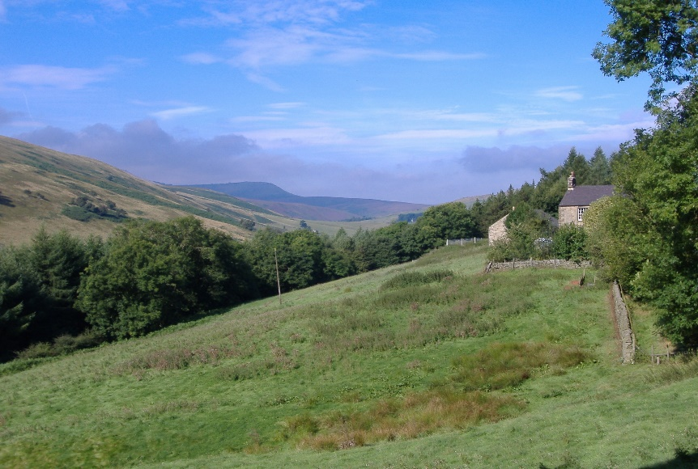

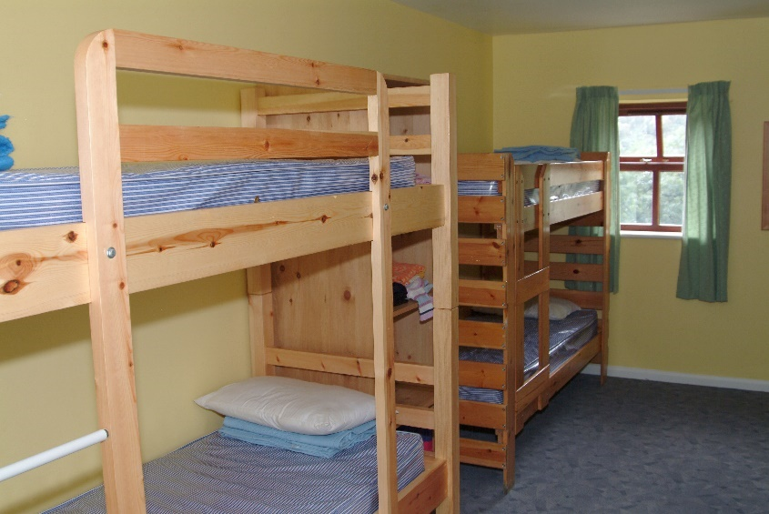

Bleasby C of E Primary School

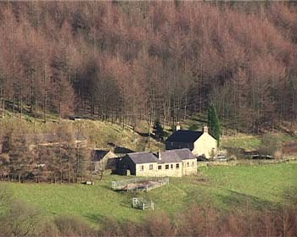

Year 6 Residential Visit

Hagg Farm

20th – 22nd July 2026

Parental Consent

Please ensure that your EVC form is up to date. Without these forms we are unable to take your child on the visit.

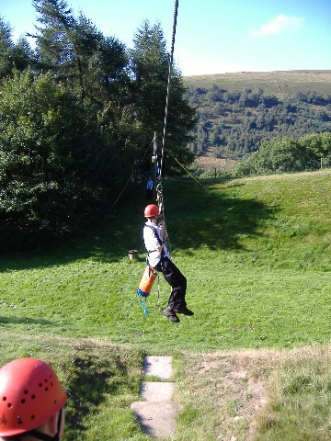

Exceptional Circumstances

In exceptional circumstances we reserve the right to ask you to fetch your child home from the visit if we feel their behaviour is putting the safety or well-being of others at risk.
Children who have to be supervised on a one-to-one basis seriously affect the staff to pupil ratio for every other child on the visit and diminish our ability to supervise the rest of the party safely.
As responsible parents we are sure you will agree that the safety of your child should not be compromised by the behaviour of another.
The cost of any such sanction (as a last resort) would be borne by you, as parents.

Sleeping Arrangements
ALL bed linen is provided. But please ensure your child has towels. The rooms contain bunk beds, usually sleeping 4, 6 or 8 and these will be allocated appropriately. The staff, whose bedrooms are near the children’s, will be immediately available in case of illness or any other problem, which may occur in the night.
There will only be Bleasby School at the centre during our stay, and activity groups will be made up only from our school. Hagg Farm is hired for our exclusive use at all times. Members of the public have no access to the centre and all external doors remain locked at all times.
Children will be placed in friendship groups as far as possible.

Meals
All meals are prepared and cooked by the centre’s catering staff and one main choice is available. The children will eat in the dining room ‘self-service’ style. The children will be responsible for clearing away their own crockery and cutlery and will have a duty rota for pot washing.
No sweets or snacks are allowed on the bus. Please do not send any additional food of any kind – your children will get enough to eat! Please provide a strong container, marked with your child’s name, to carry a drink in. Suitable bottles are available from camping shops at a cost of £4 or so. Please do not send empty pop bottles as these are not strong enough – they leak or split when children sit on or throw them around (we know from experience!).

Pocket Money

The children will have the opportunity to spend a limited amount of money. Souvenirs are available from the Hagg Farm shop on the final evening. These include pocket money items such as pencils and other novelties. There will also be chance to buy ice-cream or sweets and souvenirs from the shop at Fairholmes on the final day. We feel therefore that a maximum of £15 is a reasonable limit to set and should cover any eventuality. In the interests of fairness, we ask you not to exceed this amount. A banking system will operate daily so children may withdraw small amounts at a time for sweets, and be encouraged to budget sensibly. Please would you provide their spending money in a named envelope in £1 coins or other loose change and hand it to a member of staff before departure.

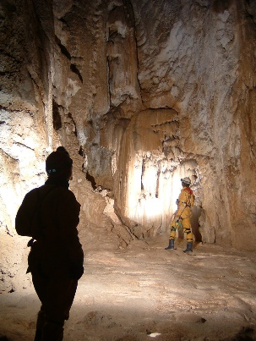

Staff accompanying the party

The members of staff accompanying the party from Bleasby will be: Mrs Spencer, Mrs Cast, Mrs Maloney and Mrs Vickers.

All staff and helpers are DBS checked; permanent staff at Hagg Farm are also first aid trained and experienced visit leaders.

Equipment
In previous years the one thing we have learnt is that you can’t guarantee the English weather – even in July! Hagg Farm provides all specialist clothing and equipment for activities. On arrival, pupils will be issued with walking boots, rucksacks, waterproof jackets and trousers.
Footwear: Please ensure your child has strong trainers with good soles for free time outdoors.
Waterproofs: These are useful for general wear, but for all wet/muddy activities Hagg Farm provides full waterproof gear.
General clothing: As a general rule, the older the better. This way, anything that gets wrecked can simply be thrown away. It is not a fashion parade and children should not have to worry about getting into trouble for spoiling new clothing. Charity shops and discount clothing stores are ideal! Lots of layers! In an active week, most children need more clothes than they would normally use at home. If in doubt – pack it!
Cold weather: Hats and gloves are useful for keeping the heat in when waiting in turn and for evening events.
Hot weather: Sun cream, hats and glasses please.
AND insect repellent – very important. Hagg Farm is susceptible to midges, particularly in the evenings when children are playing outside.
Please ensure all clothing and personal items are named – they are easily mislaid in shared rooms and children are very reluctant to claim dirty underwear!
Children must not bring electronic devices or mobile phones as we cannot guarantee their safety from loss, theft or breakage. There is NO mobile signal at Hagg Farm.
Cameras are allowed as long as the children realise they are totally responsible for their own equipment.
Small travel games/cards etc. are welcome.

Responsibilities and duties

All the children are expected to be responsible for their own belongings throughout the visit; they are also expected to be responsible towards each other and the group as a whole.
Duties in the centre will be to keep their rooms tidy and organised and to behave in a responsible way. They should respect each other and other children’s belongings. They should also respect the privacy of other rooms and their occupants. Other duties, by rota, include setting tables, cleaning up and washing pots!
A residential visit is a valuable experience in community living which requires both independence and co-operation at the same time! Everyone has to help each other and be responsible for organising themselves – it is an important part of personal and social education, part of growing up.

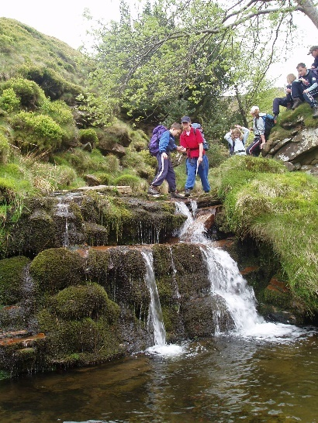

Itinerary

 | Morning | Afternoon | Evening
Monday  20th July | Depart  9am  Arrive Hagg Farm  approx 11.00am | Arrival procedures, kit allocation and first activity from:  Canoeing  Caving/Rock Hop  Orienteering/ Bushcraft | A choice from:  Night line Firepit  Night walk
Tuesday  21st July | Rotated group activities to include:  Orienteering/Bushcraft  Canoeing  Caving/Rock Hop |  | A choice from:  Night line  Firepit  Night walk  Boot wash
Wednesday  22nd July | Hike to Fairholmes  Lunch  Ice-cream  Shop | Depart 1:00pm  Return  3.15pm  approx
Personal Equipment List

LARGE BAG/CASE containing:
Night clothes
Underwear and socks for 3 days (plus spares)
2 warm jumpers/sweatshirts
Warm hat, gloves and scarf
3 long sleeved tops (essential for some activities)
3 pairs trousers/leggings/joggers (not jeans)
3 T-shirts
Handkerchief/tissues
1 pair indoor shoes
1 pair outdoor shoes/trainers
2 pairs shorts
2 Large bath/swimming towels
Swimwear
2 Hand towels
Toiletries – in a bag
Large, strong plastic bags (named) for dirty/wet clothes
Sun cream & insect repellent
Sun hat/cap/glasses + hat and gloves
Fleece tops (without hoods!)
Warm waterproof coat
Torch
SMALL RUCKSACK containing:
Purse or envelope – named and containing up to £15
Medicines – with name and instructions
Drink in container (no glass thermos flasks)
Camera
Cagoule/waterproof
Asthma inhaler if necessary
Packed lunch for first day
Medical needs

Please ensure you have informed a member of staff if your child has any medical or dietary needs. Any medicines which need to be administered should be in a named envelope, with instructions and given to a member of staff on departure. Night time tendencies also need to be mentioned to staff.
Any children requiring asthma inhalers should have their own in their rucksack and a couple of spares should be handed over to their teacher.



