a
Silver Birch Class Information w.c. 22.6.26
English:   | Summer Term Tests:  This week, the children will be completing their summer term comprehension and SPaG tests.
Maths:  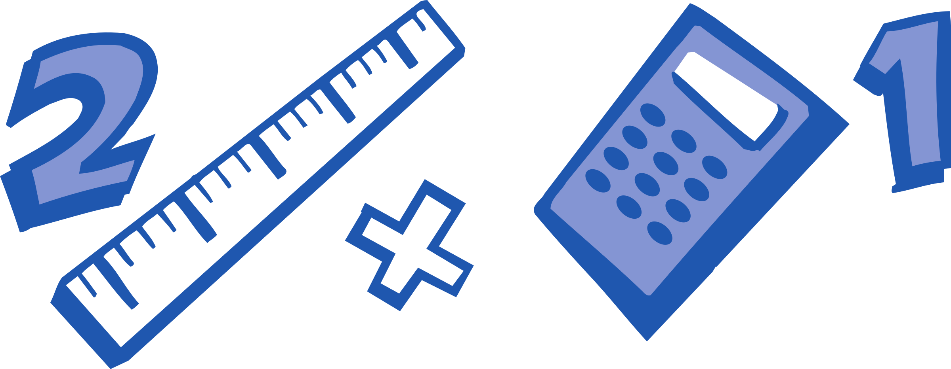 | Summer Term Tests:  This week, the children will be completing their summer term arithmetic and reasoning tests.
Enquiry:  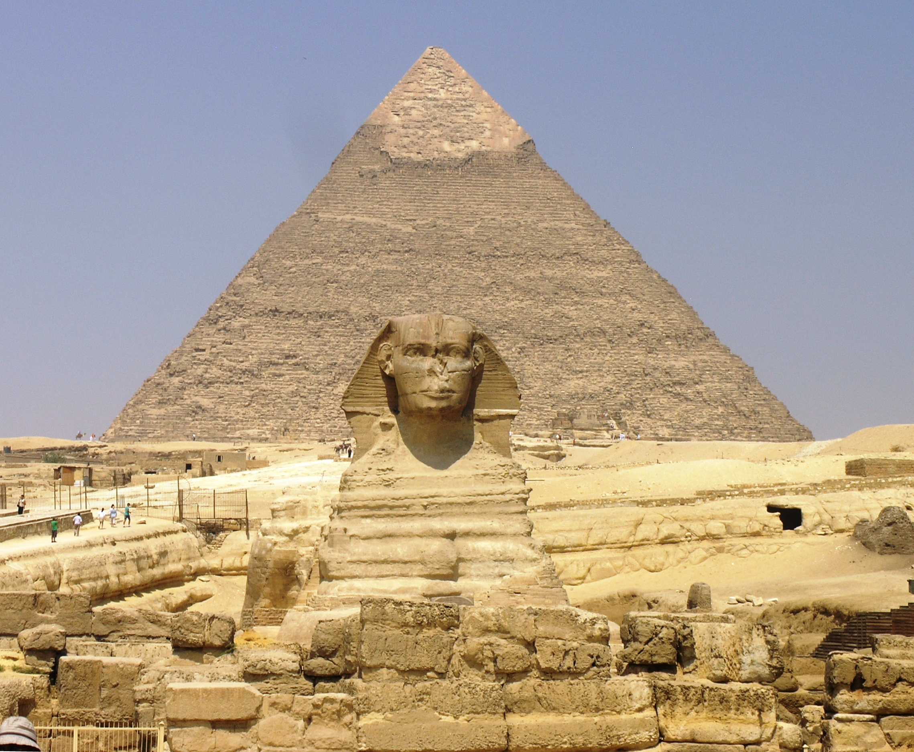 | Would you have wanted to have been an Ancient Egyptian?  This week, we will be finding out more about the mummification process and why it happened.
Science:  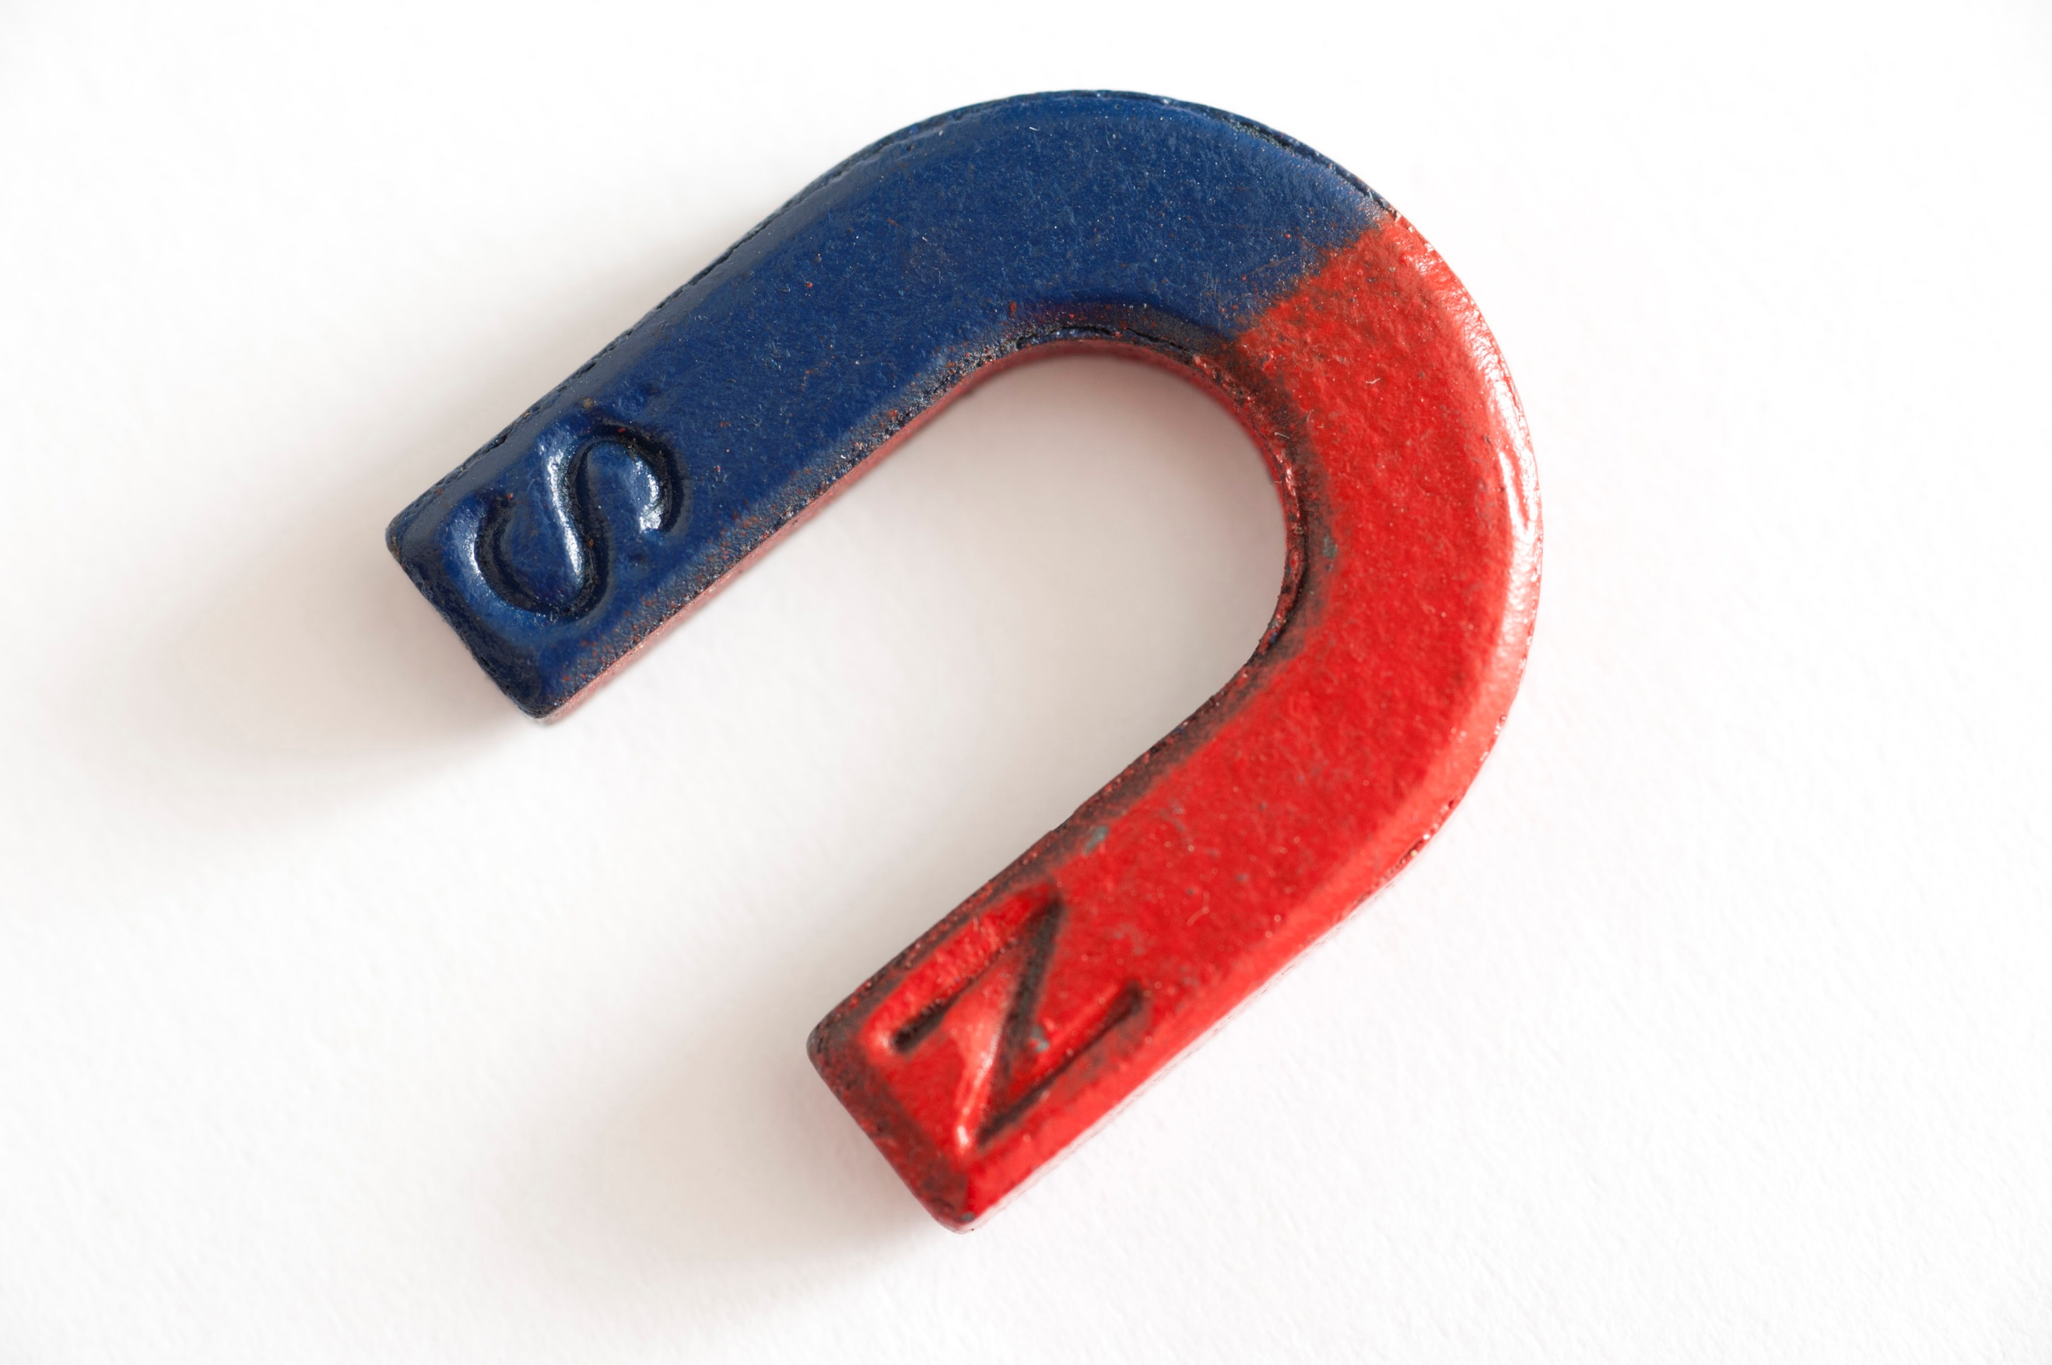 | Forces & Magnets:  This week, we will be finding out whether magnets attract or repel depending on their poles.
ART/DT:   | Designing a chariot  This week, we will be finishing and evaluating our chariots.
 | Messages:  Remember to keep learning your times tables on TT Rockstars and record your home reading in your monkey book.  Kind regards,  Mr Ryan

Silver Birch Class Information w.c. 22.6.26
English: | Summer Term Tests:  This week, the children will be completing their summer term comprehension and SPaG tests.
Maths: | Summer Term Tests:  This week, the children will be completing their summer term arithmetic and reasoning tests.
Enquiry: | Would you have wanted to have been an Ancient Egyptian?  This week, we will be finding out more about the mummification process and why it happened.
Science: | Forces & Magnets:  This week, we will be finding out whether magnets attract or repel depending on their poles.
ART/DT: | Designing a chariot  This week, we will be finishing and evaluating our chariots.
Messages:
Remember to keep learning your times tables on TT Rockstars and record your home reading in your monkey book.

Kind regards,
Mr Ryan

