Silver Birch Class Information w.c. 15.6.26
English:   | The Story of Tutankhamun  This week, we will be continuing the narrative version of ‘The Story of Tutankhamun.’ We will be writing a character profile of Howard Carter, writing a letter in the present perfect tense and using expanded noun phrases to describe the tomb.
Maths:  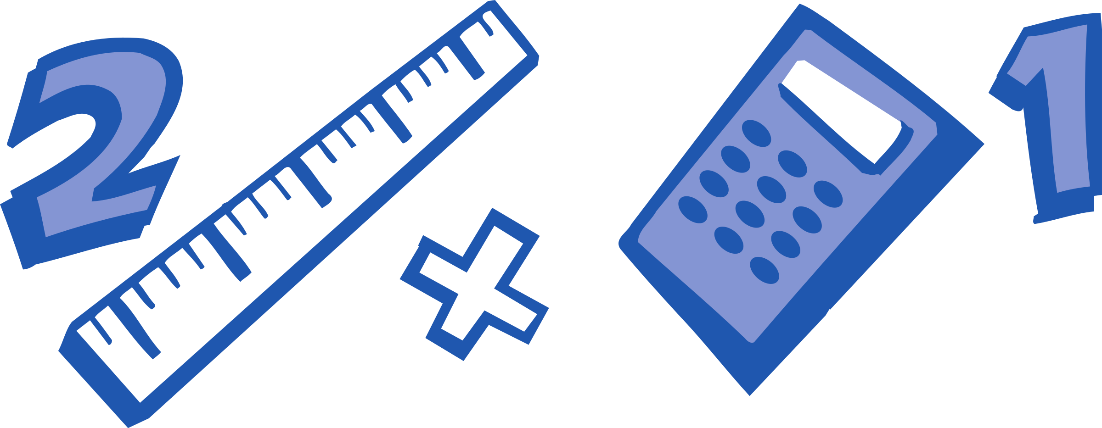 | Year 2: Statistics  - Draw pictograms  - Interpret pictograms  - Block diagram revision  - Pictogram revision.  Year 3: Statistics  - Interpret pictograms  - Draw pictograms  - Interpret bar charts  - Draw bar charts
Enquiry:  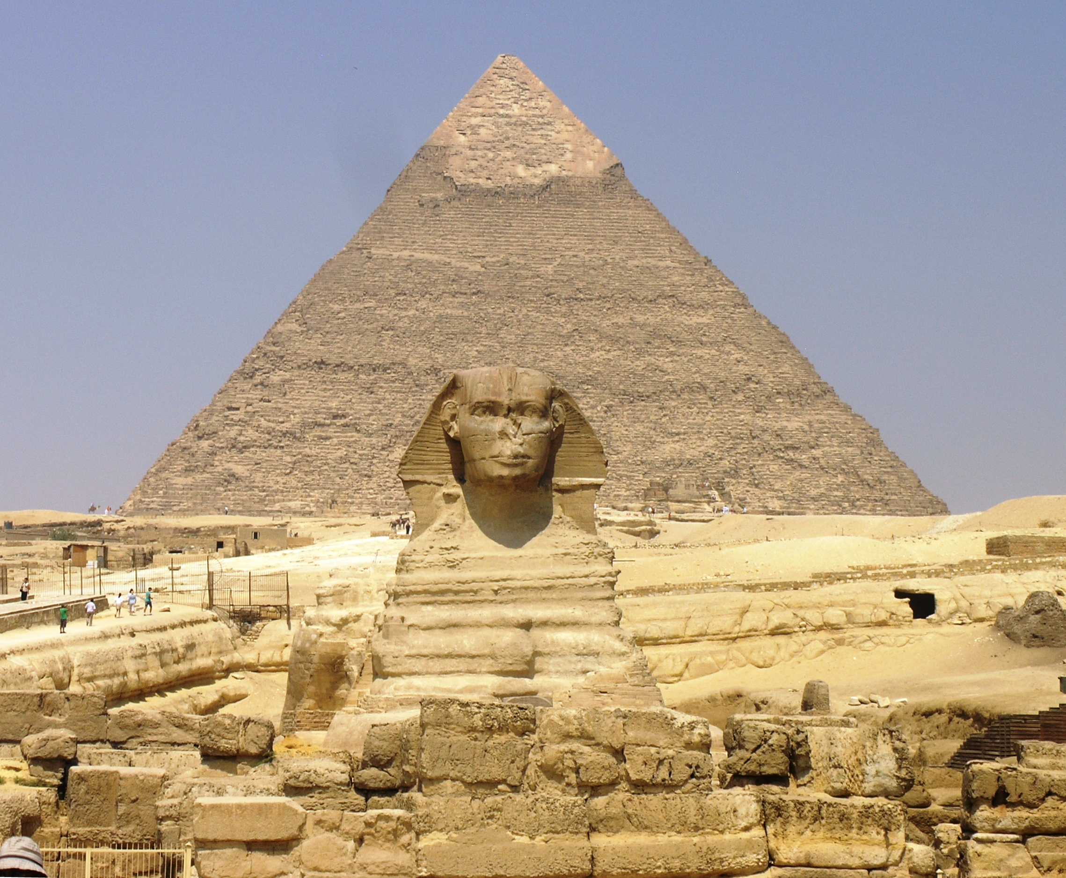 | Would you have liked to have been an Ancient Egyptian?  On Tuesday, it is our Egyptian day. We will be completing sessions on mummification, games, dances, stories and more!
ART/DT:   | Designing  This week, we will be creating our D.T chariots based on the designs we have created.
 | Messages:  Remember to keep learning your times tables on TT Rockstars and record your home reading in your monkey book. Don’t forget it is Egyptian day tomorrow!  Kind regards,  Mr Ryan

Silver Birch Class Information w.c. 15.6.26
English: | The Story of Tutankhamun  This week, we will be continuing the narrative version of ‘The Story of Tutankhamun.’ We will be writing a character profile of Howard Carter, writing a letter in the present perfect tense and using expanded noun phrases to describe the tomb.
Maths: | Year 2: Statistics  - Draw pictograms  - Interpret pictograms  - Block diagram revision  - Pictogram revision.  Year 3: Statistics  - Interpret pictograms  - Draw pictograms  - Interpret bar charts  - Draw bar charts
Enquiry: | Would you have liked to have been an Ancient Egyptian?  On Tuesday, it is our Egyptian day. We will be completing sessions on mummification, games, dances, stories and more!
ART/DT: | Designing  This week, we will be creating our D.T chariots based on the designs we have created.
Messages:
Remember to keep learning your times tables on TT Rockstars and record your home reading in your monkey book. Don’t forget it is Egyptian day tomorrow!

Kind regards,
Mr Ryan

