Silver Birch Class Information w.c. 8.6.26
English:   | The Story of Tutankhamun  This week, we will be continuing the narrative version of ‘The Story of Tutankhamun.’ We will be planning, researching and writing our own chronological reports.
Maths:  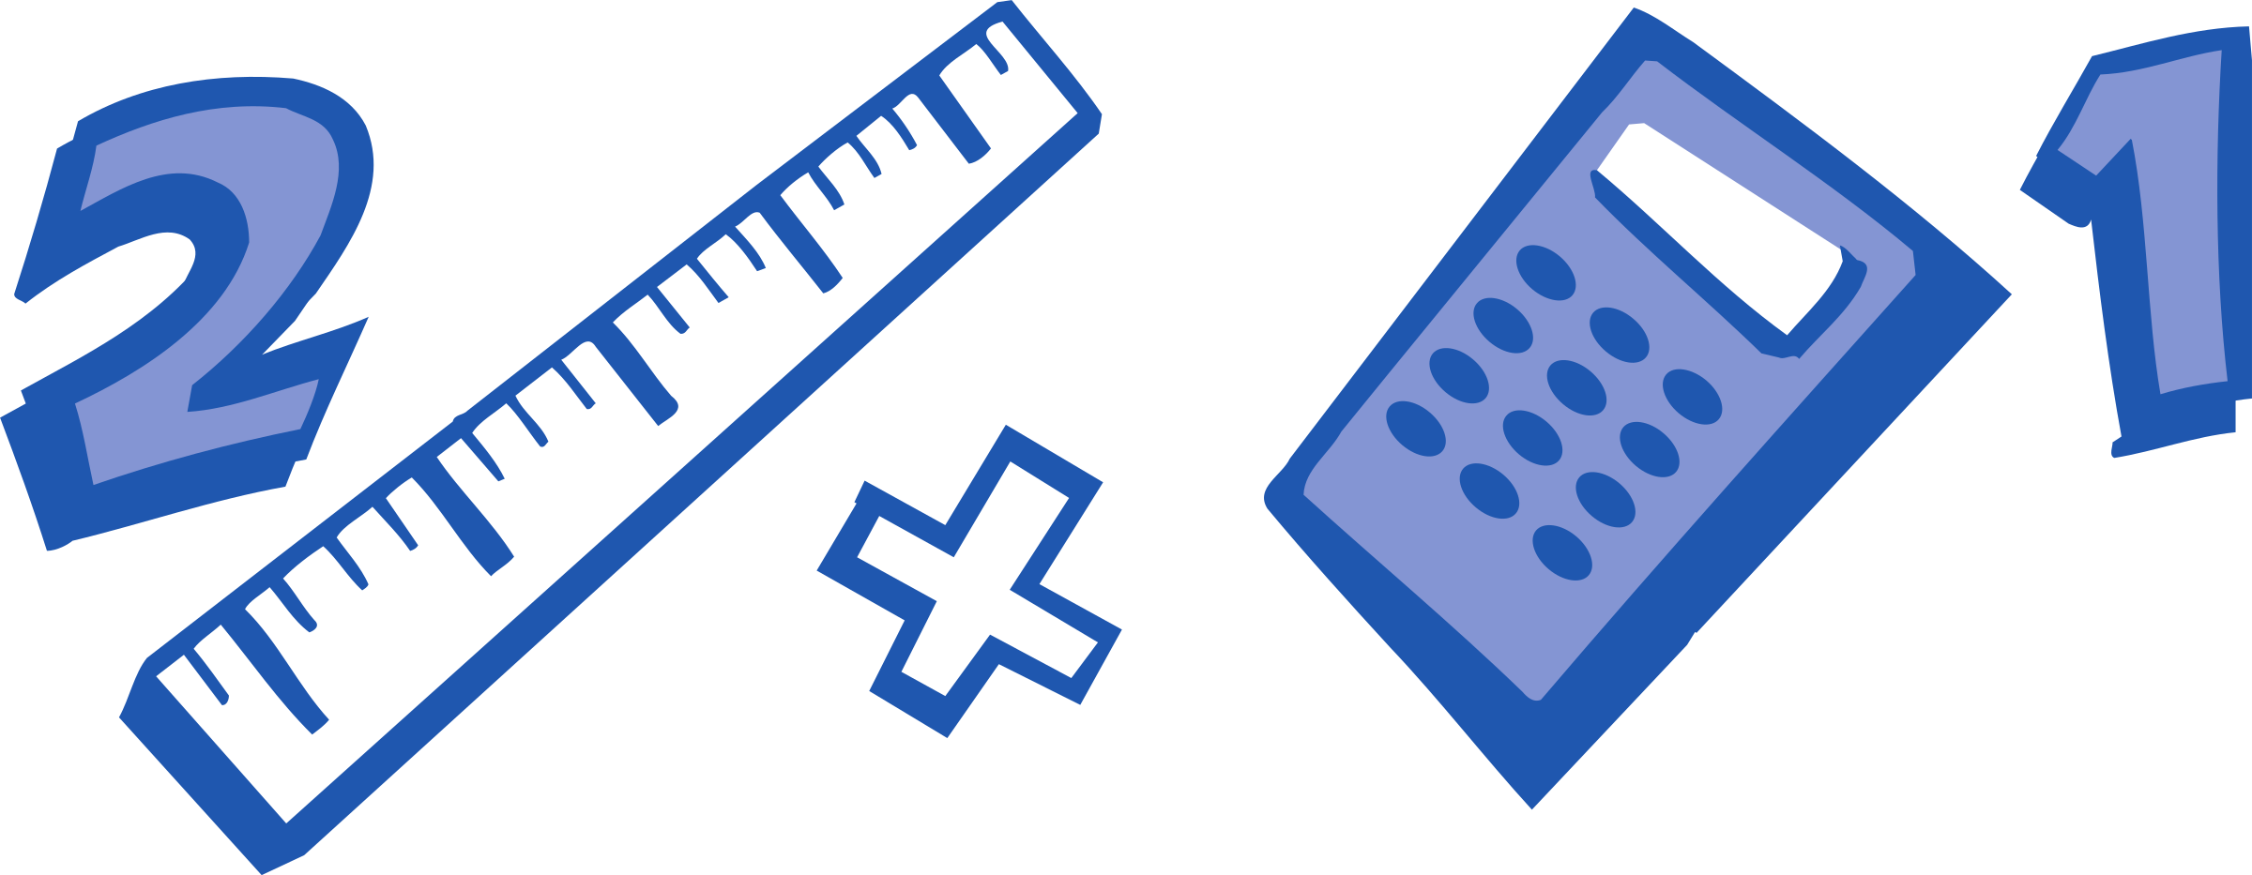 | Year 2: Statistics – 1. Tally charts  2. Tables  3. Block Diagrams  4. Drawing pictograms  5. Intercepting pictograms  Year 3: Time 6. Days and Hours  7. Hours and minutes – start and end points  8. Hours and minutes – durations  9. Minutes and seconds
Enquiry:  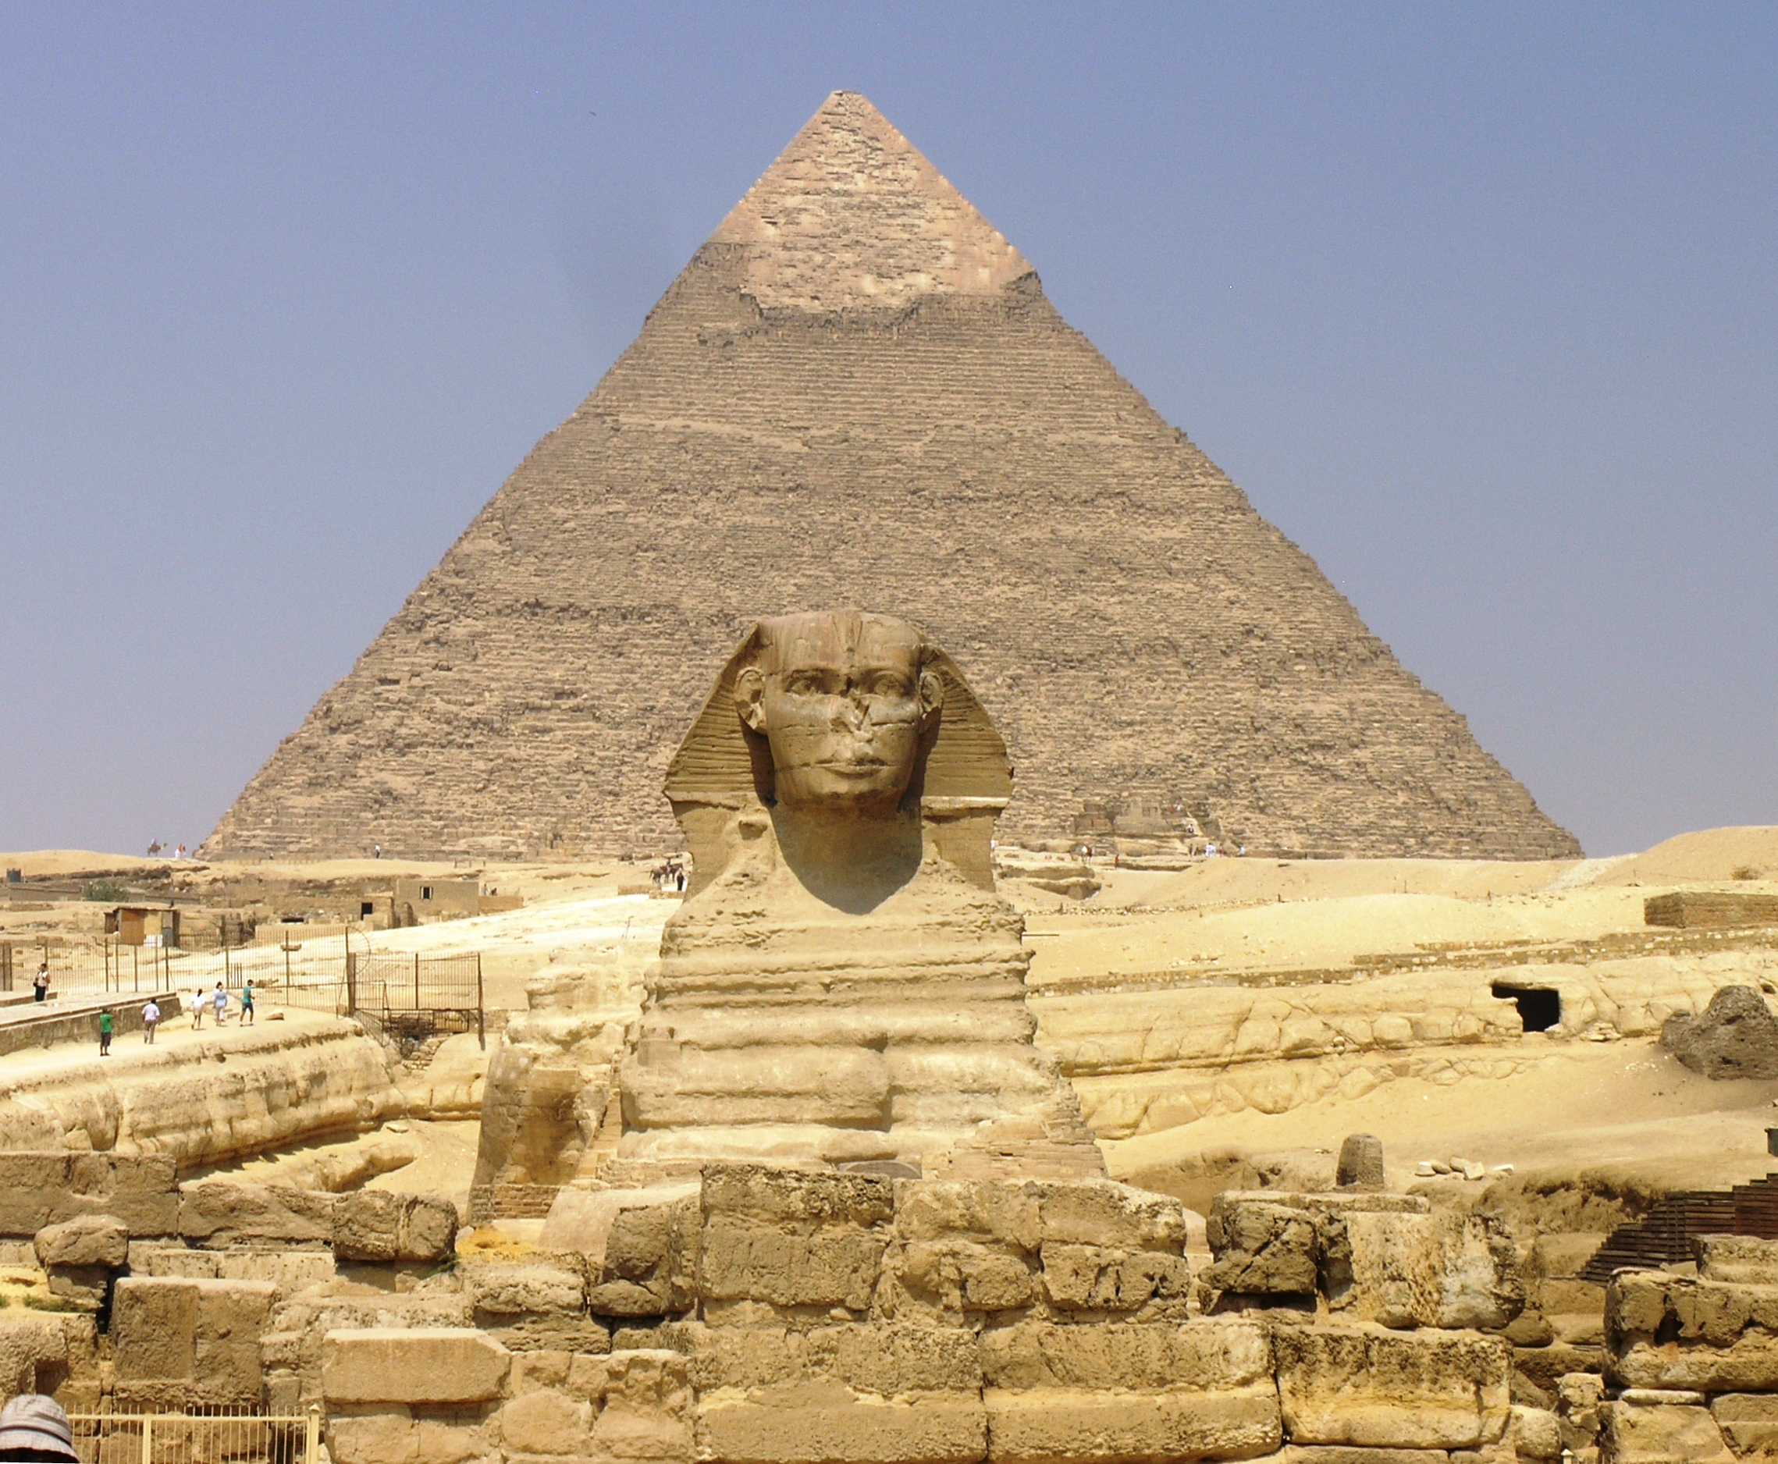 | Would you have wanted to have been an Ancient Egyptian?  This week, we will become archaeologists. We will be finding out about the many discoveries of ancient Egypt including the Valley of The Kings.
Science:  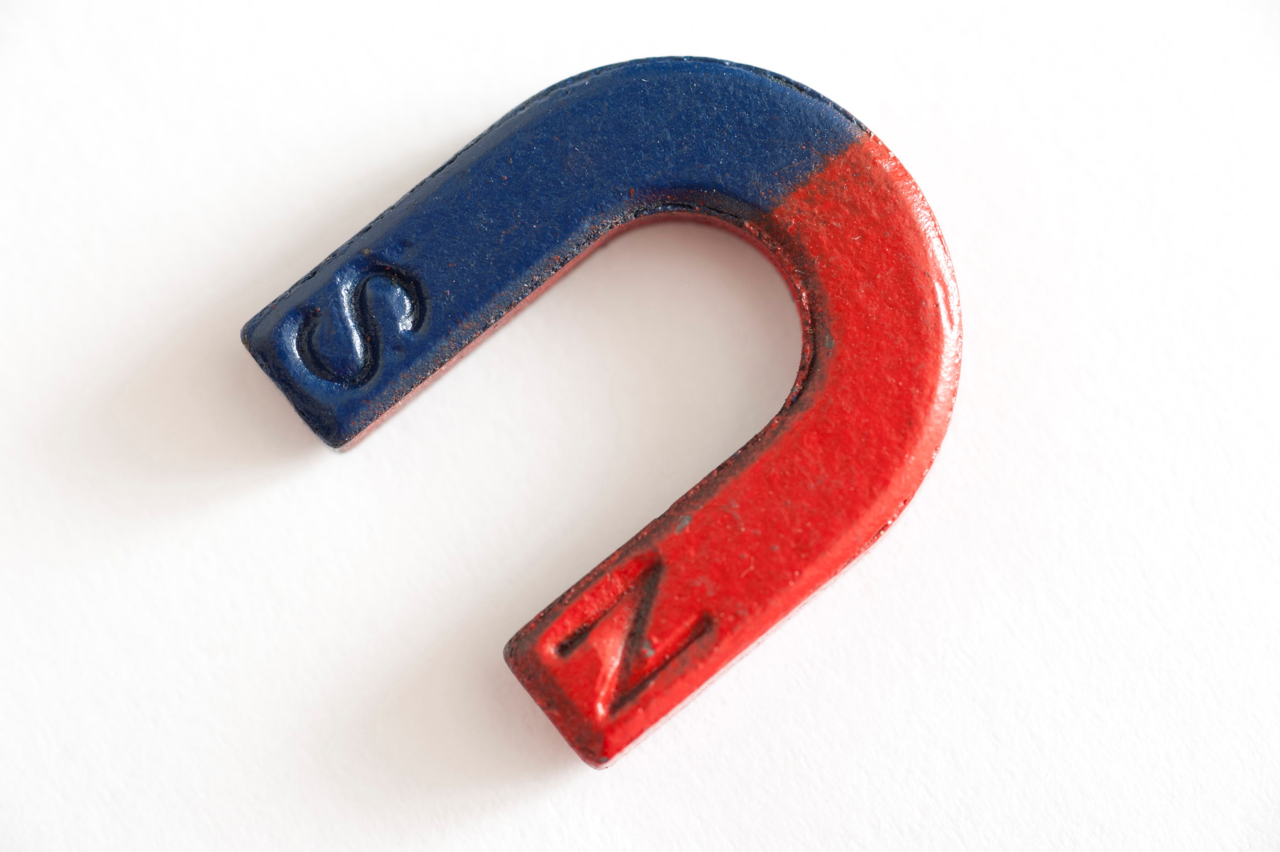 | Forces & Magnets:  This week, we will be finding out how to compare magnetic and non-magnetic materials.
ART/DT:   | Designing  This week, we will be
 | Messages:  Remember to keep learning your times tables on TT Rockstars and record your home reading in your monkey book.  Y3 Children have Swimming on Friday.  Kind regards,  Mr Ryan

Silver Birch Class Information w.c. 8.6.26
English: | The Story of Tutankhamun  This week, we will be continuing the narrative version of ‘The Story of Tutankhamun.’ We will be planning, researching and writing our own chronological reports.
Maths: | Year 2: Statistics – 1. Tally charts  2. Tables  3. Block Diagrams  4. Drawing pictograms  5. Intercepting pictograms  Year 3: Time 6. Days and Hours  7. Hours and minutes – start and end points  8. Hours and minutes – durations  9. Minutes and seconds
Enquiry: | Would you have wanted to have been an Ancient Egyptian?  This week, we will become archaeologists. We will be finding out about the many discoveries of ancient Egypt including the Valley of The Kings.
Science: | Forces & Magnets:  This week, we will be finding out how to compare magnetic and non-magnetic materials.
ART/DT: | Designing  This week, we will be
Messages:
Remember to keep learning your times tables on TT Rockstars and record your home reading in your monkey book.
Y3 Children have Swimming on Friday.

Kind regards,
Mr Ryan

