

Bleasby CE Primary School
Station Road, Bleasby, Nottinghamshire, NG14 7GD
Tel: 01636 830203 email office@bleasbyprimary.org.uk
Visit: www.bleasbyprimary.co.uk

Y6 Stepping up visit to Southwell Minster Church - Wednesday 15th July 2026

Dear Parents and Carers,
We will be taking the Year 6 children to visit Southwell Minster Church for a KS2 Stepping up event on Wednesday 15th July 2026 as part of their transition to secondary school.
On this special visit, away from the end of year whirlwind, there’s time for quiet reflection, sharing memories, hopes and dreams through the Minster trail, craft and storytelling workshops in beautiful surroundings. There will also be the opportunity for Collective worship and some songs.
The visit will take place within the school day. Your child will need to wear school uniform. They also need to bring their own packed lunch, a drink and perhaps a mid-morning snack (optional). If it is a hot day, please bring a hat and wear sun protection as we may eat our lunch as a picnic in the grounds. We will travel to Southwell by coach. If your child suffers from travel sickness, please make sure they have the necessary medication.
The cost of the visit, including the coach (£225) and the Southwell Minster event fee (£8.00pp), will be a voluntary contribution of £18.23 per child. Mrs Meaden will set this up on School Money this week.
School will need to have an up-to-date EV4 medical form for your child in order for them to go on this visit. Please let us know if there are any changes to the forms you completed at the start of the academic year. If your child needs an inhaler, please ensure they bring it with them on the day and have it in a safe place in their bag.
Please can you pay for the visit on School Money and tick the parental consent option by Monday 6th July 2026.
Parent volunteers:
If you would like to accompany us on this visit, and have a DBS check, please let me know.
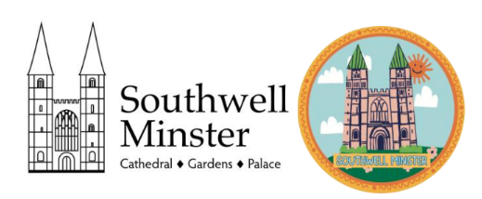
Many thanks,
Mrs Spencer

