Silver Birch Class Information w.c. 04.05.26
English:   | Cinderella of The Nile  This week we will be continuing the text on Cinderella of The Nile by Berverley Naidoo. We will be writing using the four sentence types, planning a sequence of events and using literary language to describe characters and settings.
Maths:   | Year 2: Fractions  Finding one quarter, finding three quarters, count in fractions up to a whole.  Year 3:  Fractions B: 7. To know non-unit fractions of an amount  Money: Pounds and pence, converting pounds and pence, converting money.
Enquiry:  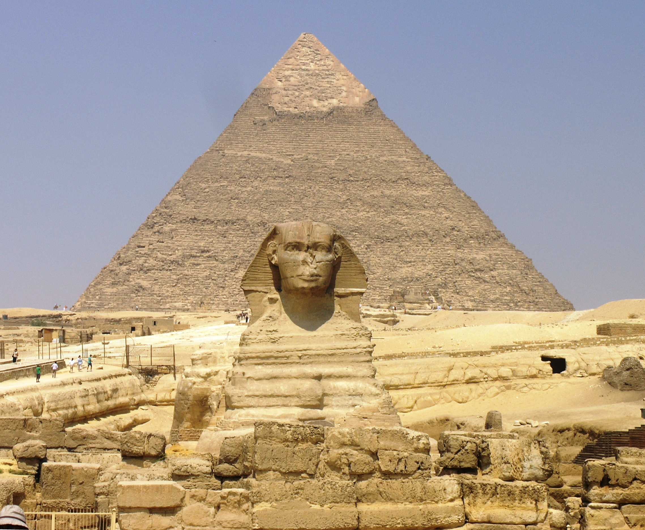 | Would you have wanted to have been an Ancient Egyptian?  This week, we will be finding out more about who the Ancient Egyptians were by studying various artefacts.
Science:  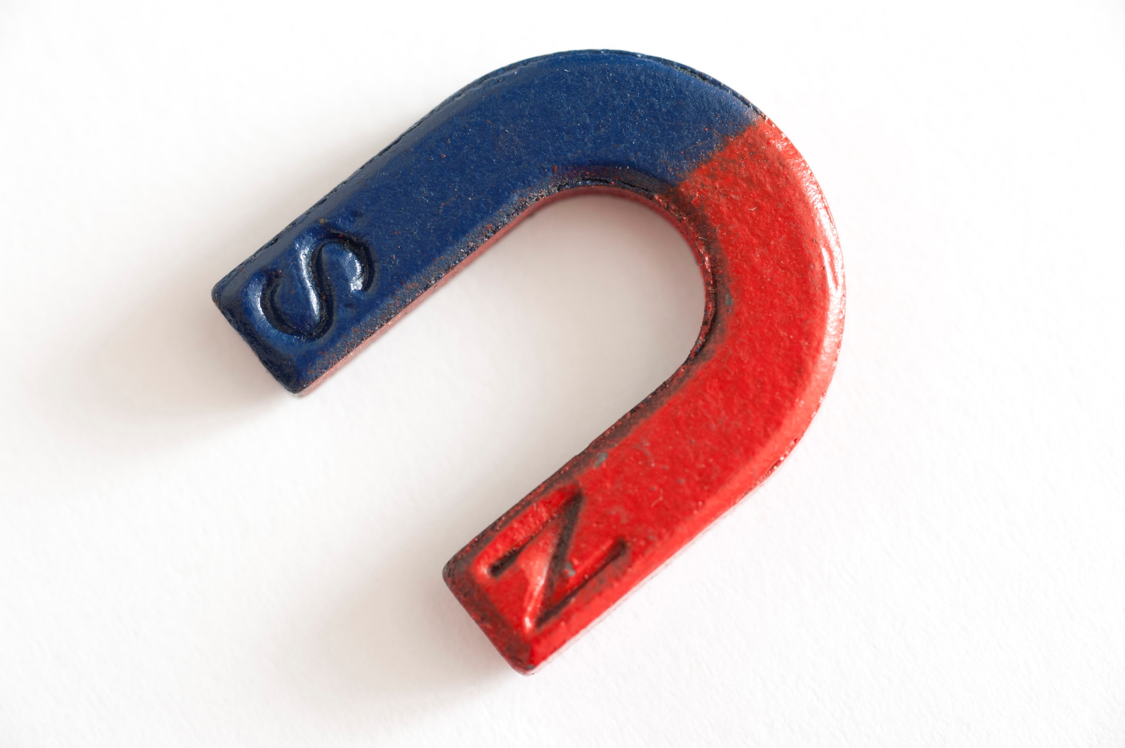 | Forces & Magnets:  This week, we will be finding out how surfaces affect the movement of objects travelling on them.
ART/DT:   | 3D Modelling:  To know use watercolour paints to create a wash over our pyramid images. Use colours to represent the desert.
 | Messages:  This term, we are doing touch typing in computing. See if you can get even quicker on Purple Mash at home! Don’t forget to keep recording in your Monkey Book at home for extra house points as well.  Kind regards,  Mr Ryan

Silver Birch Class Information w.c. 04.05.26
English: | Cinderella of The Nile  This week we will be continuing the text on Cinderella of The Nile by Berverley Naidoo. We will be writing using the four sentence types, planning a sequence of events and using literary language to describe characters and settings.
Maths: | Year 2: Fractions  Finding one quarter, finding three quarters, count in fractions up to a whole.  Year 3:  Fractions B: 7. To know non-unit fractions of an amount  Money: Pounds and pence, converting pounds and pence, converting money.
Enquiry: | Would you have wanted to have been an Ancient Egyptian?  This week, we will be finding out more about who the Ancient Egyptians were by studying various artefacts.
Science: | Forces & Magnets:  This week, we will be finding out how surfaces affect the movement of objects travelling on them.
ART/DT: | 3D Modelling:  To know use watercolour paints to create a wash over our pyramid images. Use colours to represent the desert.
Messages:
This term, we are doing touch typing in computing. See if you can get even quicker on Purple Mash at home! Don’t forget to keep recording in your Monkey Book at home for extra house points as well.

Kind regards,
Mr Ryan

