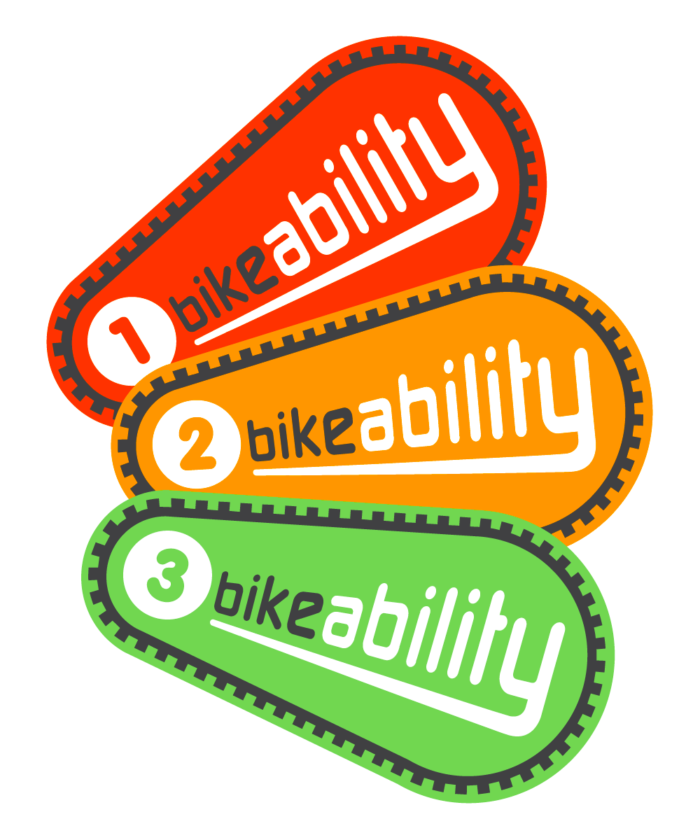
Bikeability Training for Year 6
Dates: Group 1 – Thurs 9th July and Fri 10th July Group 2 – Mon 13th July and Tues 14th July

Dear Parents, Grandparents and Carers,

Great News! We are pleased to inform you that we will be offering Bikeability cycle training to Year 6 pupils this term. This is a nationally recognised programme is designed to help children develop essential cycling skills and build the confidence they need to ride safely and responsibly on the road.

The training will be delivered by qualified instructors and will focus on key areas such as bike control, road awareness and safe cycling techniques. The sessions are free of charge, however late cancellations may incur a charge. (T&C’s applied).

To take part in Levels 1 and 2, your child will preferably be able to ride independently and have their own cycle in a roadworthy condition, with two working brakes and a helmet. If you child does not have access to a suitable bike but would still like to participate, please contact the school office as soon as possible to request a cycle/helmet from the Training Provider. This may not be possible if insufficient notice is given.

All Balances bikes and helmets will be provided by the Training Provider.

Riders should dress appropriately for the weather conditions, sensible footwear and bring any medication required – please inform the school.

To enrol your child, please complete the Cycle Consent form using one of the links below. If you’re unable to complete the form online, please get in touch as soon as possible.

- URL: https://consent.bikeability.org.uk/lie-ward-main
- Or scan the QR code:
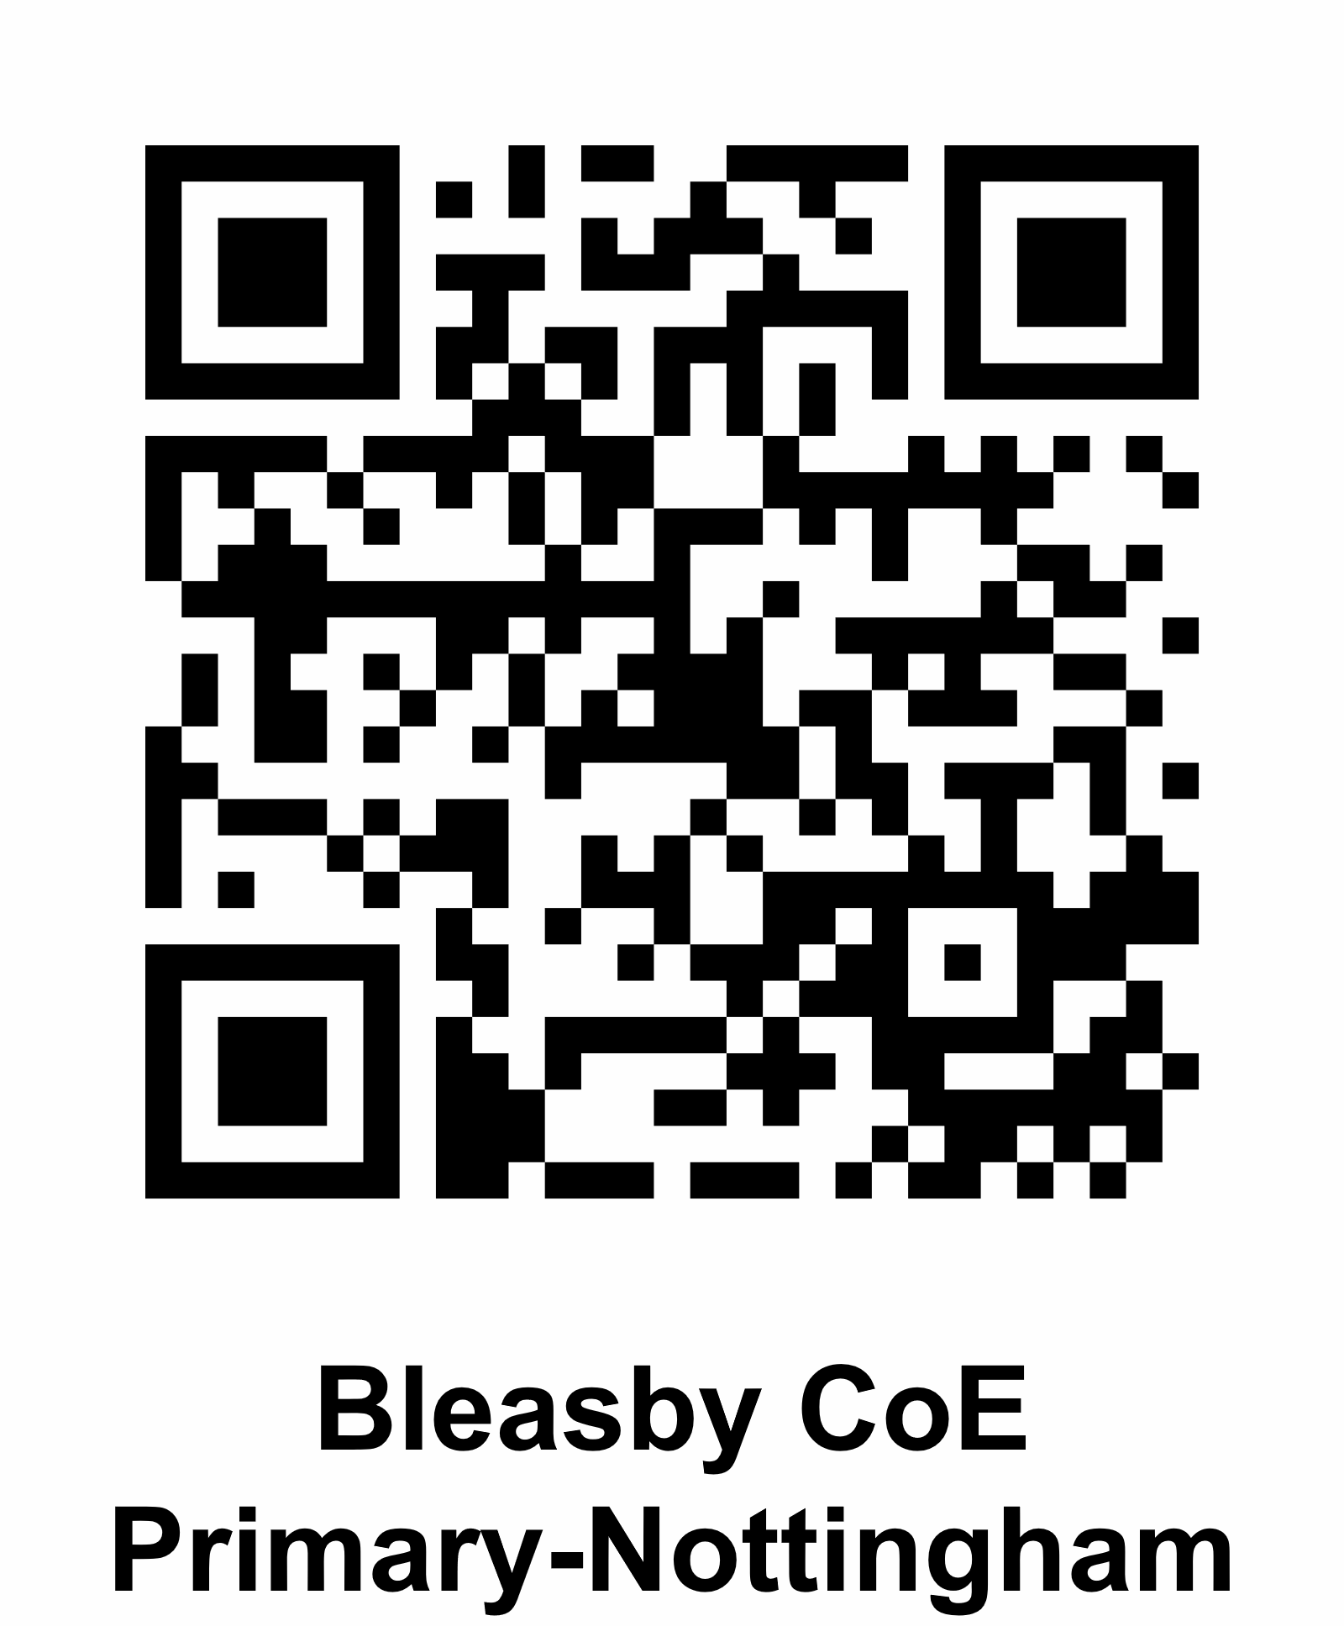

The consent form contains five short sections. While it may seem like a lot, it should only take a few minutes to complete.

- Rider details.
- Cycling ability and frequency.
- Bike and kit check.
- SEND and medical information.
- Parental consent.
Failure to complete this form will unfortunately result in your child being unable to take part in Bikeability cycle training.

If you have any questions or need further information, please don’t hesitate to contact us.

