Silver Birch Class Information w.c. 20.04.26
English:   | Cinderella of The Nile  This week, we will be starting our new text on Cinderella of The Nile by Berverley Naidoo. We will be identifying and using literary language, inferring a character’s feelings and using imperative verbs to create commands.
Maths:  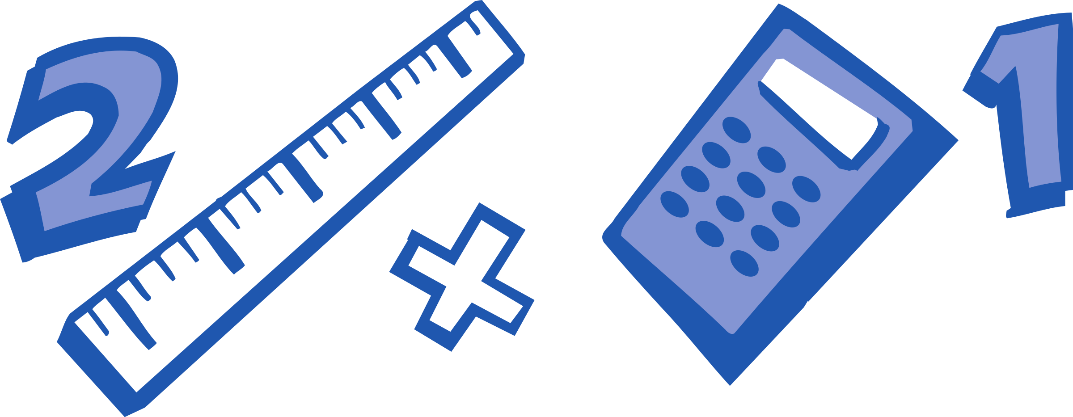 | Year 2: Fractions  Finding quarters, recognising thirds, finding thirds, finding a whole, unit fractions.  Year 3: Mass & Capacity  3. To know equivalent masses.  4. To know how to compare masses  5. To know how to add and subtract mass  6. To know how to measure capacity and volume in ml. 7. To know equivalent capacities and volumes
Enquiry:  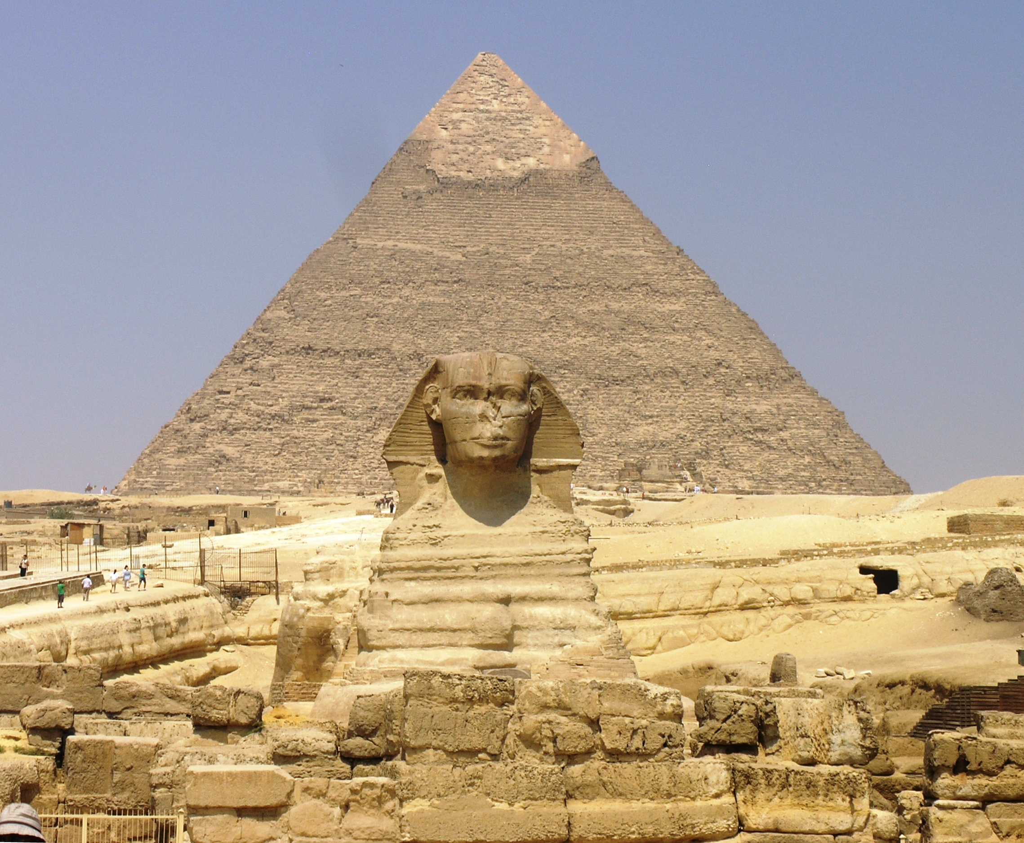 | Would you have wanted to have been an Ancient Egyptian?  This week, we will be finding out where in the world Egypt is, using our geography skills.
Science:  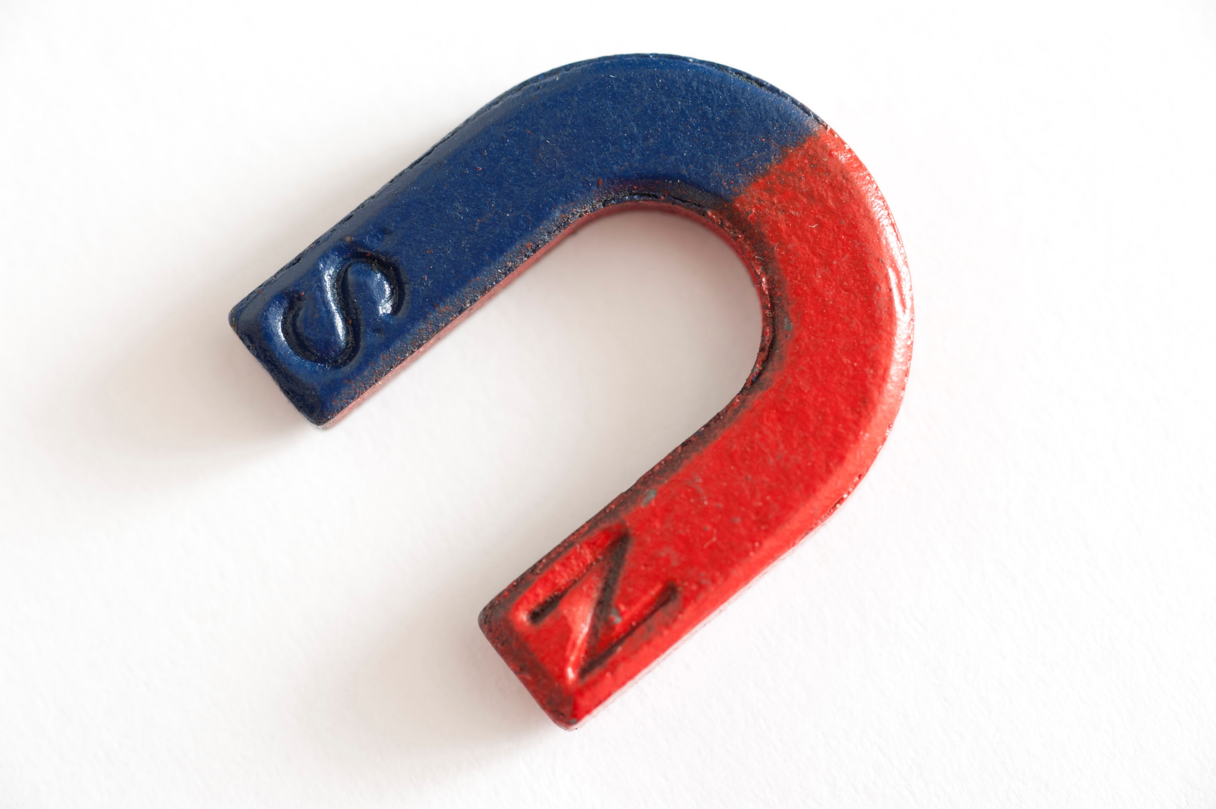 | Forces & Magnets:  This week, we will be finding out why surfaces are suitable for different jobs and give examples from real life.
ART/DT:   | 3D Modelling:  Over the next few weeks, we will be using different materials to create different objects inspired by the Egyptians.
 | Messages:  This term, we are doing touch typing in computing. See if you can get even quicker on Purple Mash at home! Don’t forget to keep recording in your Monkey Book at home for extra house points as well.  Kind regards,  Mr Ryan

Silver Birch Class Information w.c. 20.04.26
English: | Cinderella of The Nile  This week, we will be starting our new text on Cinderella of The Nile by Berverley Naidoo. We will be identifying and using literary language, inferring a character’s feelings and using imperative verbs to create commands.
Maths: | Year 2: Fractions  Finding quarters, recognising thirds, finding thirds, finding a whole, unit fractions.  Year 3: Mass & Capacity  3. To know equivalent masses.  4. To know how to compare masses  5. To know how to add and subtract mass  6. To know how to measure capacity and volume in ml. 7. To know equivalent capacities and volumes
Enquiry: | Would you have wanted to have been an Ancient Egyptian?  This week, we will be finding out where in the world Egypt is, using our geography skills.
Science: | Forces & Magnets:  This week, we will be finding out why surfaces are suitable for different jobs and give examples from real life.
ART/DT: | 3D Modelling:  Over the next few weeks, we will be using different materials to create different objects inspired by the Egyptians.
Messages:
This term, we are doing touch typing in computing. See if you can get even quicker on Purple Mash at home! Don’t forget to keep recording in your Monkey Book at home for extra house points as well.

Kind regards,
Mr Ryan

