Construct a 3D pyramid – using any suitable materials e.g. Lego, woodblocks, card or sugar cubes etc.  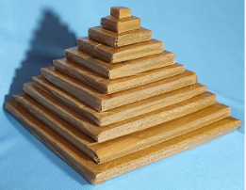 | 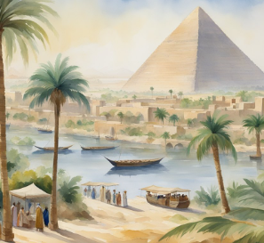  Create an illustrated list of ten things that we would see in  Ancient Egypt. | Design a leaflet to encourage a tourist to visit Egypt.  Explain some of the things they could see and do.  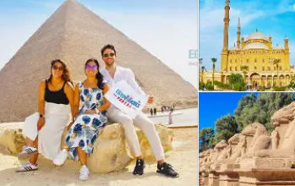 | 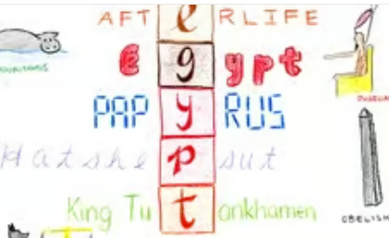  Using the words ‘Ancient Egypt’ create an acrostic poem.
Draw and label or make a 3D model of a typical home during ancient Egyptian times.  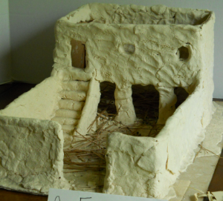 | 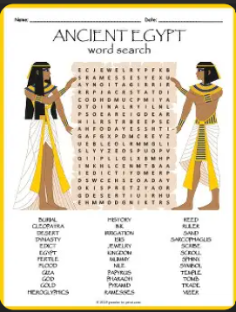  Create a word search about ancient Egypt. Make it attractive for your peers to complete. | Compose a short song or descriptive poem about Ancient Egypt or an aspect of life there.  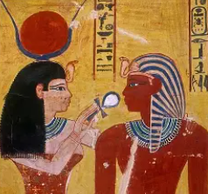 | 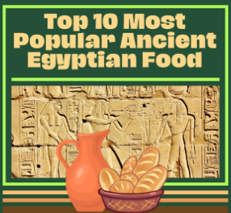  Make an illustrated list of foods or create a menu for Ancient Egyptian times.
Find out and write about one or more Ancient Egyptian musical instruments.  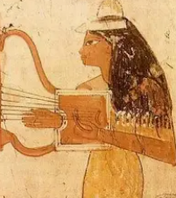 | 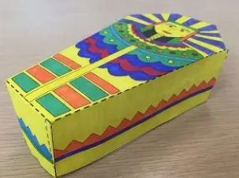  Make a beautifully decorated sarcophagus. | Make a PPT or draw & write about one or more Ancient Egyptian gods or goddesses. Explain why they were important.  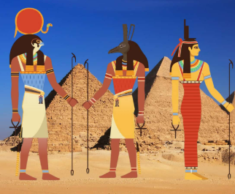 | 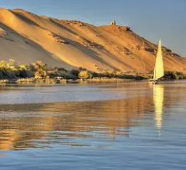  Create a fact-file on the River Nile in Ancient Egyptian times and today.
Make your own papyrus paper and draw and colour an Ancient Egyptian image on it.  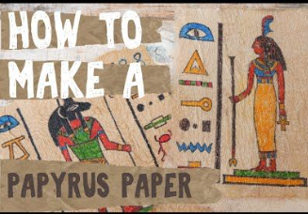 | 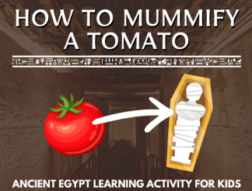  Mummify a tomato or apple and write instructions to show what you did.  Add photos! | Find out about an Ancient Egyptian King or Queen.  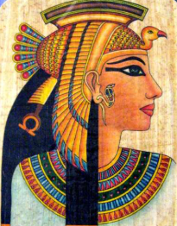 | 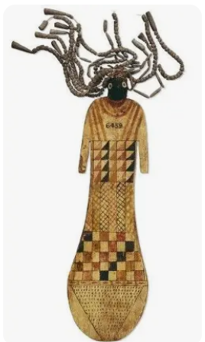  Find out about, make, draw or describe some Ancient Egyptian toys and games.

