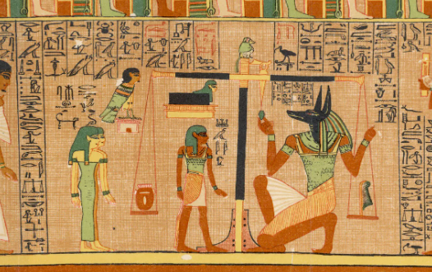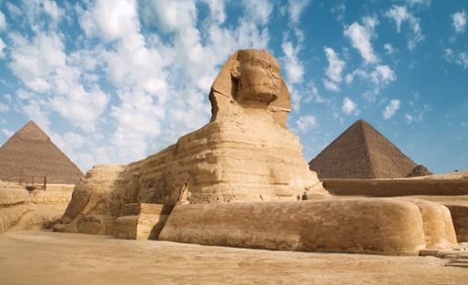
Dear Parents and Carers,
Our Enquiry Question for the Summer Term is ‘Would You Have Wanted to be an Ancient Egyptian?’
We would very much like to get started with this topic in the first week back. Our ‘Hook Day’ will hopefully whet the children’s appetites for the learning we will be undertaking.
Please could we ask that your child comes to school on Tuesday 14th April 2026 having prepared something for the day? We don’t want this to be onerous for you, but we were thinking that they could do one of the following:
- Wear a headdress, dress up as an Ancient Egyptian or bring in an AI photo of themselves dressed in this way.
- make a piece of art or craft related to Ancient Egypt
- come armed with a book, poster or a fact or two about The Ancient Egyptians.
Many thanks for supporting your child in this and we are looking forward to beginning our new topic with a bang!
Mrs Smith, Mrs Clark and Mr Ryan.

