Year 6 Leavers’ Varsity Jackets
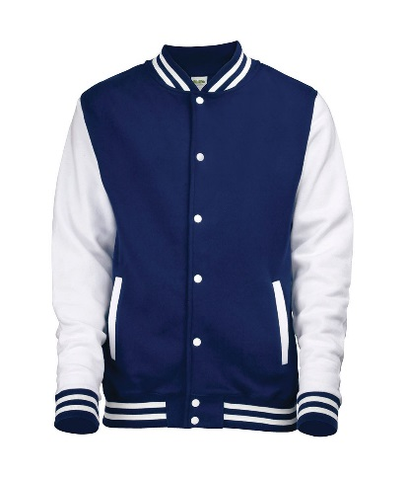
Bleasby School would like to mark the final year for the Year 6 children by allowing them to wear a varsity jacket for part of the Spring and Summer terms. As many of you know, this has happened for the past 9 years and all children have purchased a jacket to wear. The jacket will include the year the children are leavers from the school, ’26’, on the back, and will include the names of the year group, as a lasting memory for the children. ‘Bleasby School Leavers’ will be printed on the front left. The jackets will be navy and white.
The jackets will cost £19.95 for children’s sizes, or £22.75 for adult sizes, each including printing. Mrs Meaden will put the payment details on School money.
If you would like to order one for your child then please complete the order form below and return it to school by Friday 27th February 2026, with the appropriate size stated and the payment having been made on School money. I will bring some jackets from previous years for the children to try on if they are unsure about sizes.
Many thanks,
Mrs Spencer

I would like to purchase a Leavers’ Varsity Jacket for my child ____________________
Please use the School money online payment system and return this form by Friday 27th February so we can collate the orders.
Please tick the required size from the table below.
Age/Size | 7-8 | 9-11 | 12-13 | Small adult | Medium adult | Large adult

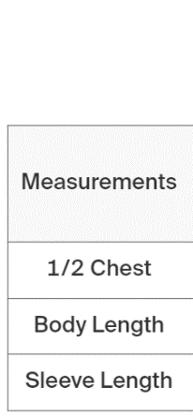
Size guide
Children’s sizes Adult sizes


