Bleasby C.E. Primary VIPERS |  | Key Stage 2 Questions
V  vocabulary |  | What do the words ___ and ___ suggest about the character / setting / mood? Find a word in the text that means _____. Which word is closest in meaning to ____. Find a phrase which suggests that….
I  infer |  | Find and copy a group of words which show that….  How do these words___ make the reader feel?  How does the description of ___ show that they are ___? What impression of ____do you get from this paragraph? What kind of voice might this character use? What was ____ thinking when ____?  Who is telling the story?
P  predict |  | What do you think this text is going to be about?  What is happening now? What happened before this?  What does this paragraph suggest will happen next?  How will this setting influence what happens next?  Do you think ____ will happen? Explain with evidence.
E  explain | 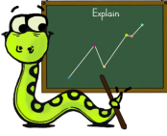 | Why is the text arranged this way?  What structures has the author used?  What is the purpose of this text feature?  Is the use of ____ effective? Why?  The mood of the character changes through the text. Find phrases that show this.  What effect does ____ have on the audience?  Which words / phrases did _____ effectively?  Which section was the most interesting / exciting and why? How are these sections / paragraphs linked?
R  retrieve | 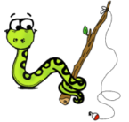 | How would you describe this text? What genre is it? How do you know?  How did…? How often…? Who has…? Who is…? Who did…? What happened to ____? What does ____ do?  From whose perspective is the story told?  What did you learn from this section?  Give one example of____.
S  summarise | 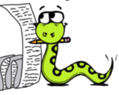 | Put these events 1-5 in the order in which they happened.  What happened after…? What was the first thing that happened in the story?  Can you summarise in a sentence this paragraph…the opening…middle…end? Order these chapter headings.

