Bleasby Church of England
Primary School

Partnership Working - Home and School

Achieving, Belonging and Caring as unique children of God, in a diverse and changing world.


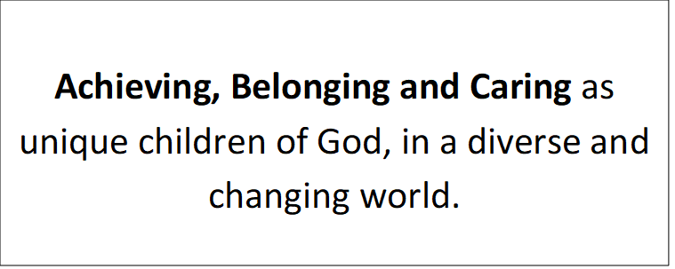

Achieving, Belonging and Caring as unique children of God, in a diverse and changing world.

Achieving, Belonging and Caring as unique children of God, in a diverse and changing world.

As a school
We will:
- Give your child opportunities and support to develop and understand our school values:
Achieving – Wisdom and Perseverance
Belonging – Friendship and Respect
Caring – Service and Compassion
- Support every child’s wellbeing and safety by providing a safe, supportive and caring environment in which they feel that they belong.
- Help and encourage your child to reach their full potential and achieve in all aspects of school life.
- Provide a broad and balanced curriculum that is designed to engage all learners and meet different needs.
- Promote high standards of behaviour, where children experience and demonstrate friendship, respect and compassion.
- Encourage good attendance and address any concerns with parents or carers.
- Set homework that supports or enhances the delivery of the curriculum.
- Offer opportunities for parents and carers to get involved in school life.
- Communicate between home and school through app, email and the school website.
- Respond to communications from parents in a timely manner, following school policies.

Signed: R.Cast Mrs Cast on behalf of the Bleasby School Staff

Parents/carers
I will do my best to:
- Support the school in expecting my child to uphold the school values:
Achieving – Wisdom and Perseverance
Belonging – Friendship and Respect
Caring – Service and Compassion
- Support every child’s wellbeing and safety by providing a safe, supportive and caring environment in which they feel that they belong; including limiting & overseeing internet use.
- Encourage my child to try their best and persevere so that they reach their full potential and achieve in all aspects of school life.
- Support the school in expecting my child to maintain high standards of behaviour, demonstrating friendship, respect and compassion.
- Make sure my child attends school regularly and on time, notifying the school if my child will be absent
- Read regularly with my child and support them in completing homework to achieve.
- Make sure my child is dressed in the correct uniform or PE kit (on PE days).
- Communicate to the school any concerns that I have about my child that may affect their behaviour in school or ability to learn.
- Treat all members of the school community with respect.
- Think carefully about use of social media, respecting the privacy of other children and the work of the school. Please contact the school if you have any concerns so that these can be quickly addressed.
- Engage in parent meetings and work together with the school in order to achieve the best outcomes for my child.

Signed: _____________ Parent of: _____________________

Pupils
I will do my best to:
- Demonstrate the school values:
Achieving – Wisdom and Perseverance
Belonging – Friendship and Respect
Caring – Service and Compassion

- Make sure that my friends and I are safe in school by listening to the adults, following rules and making wise decisions. This includes following safer internet rules at home.
- Try my best and persevere so that I reach my potential and achieve in all aspects of school life.
- Always aim for high standards of behaviour, demonstrating friendship, respect and compassion.
- Arrive at school on time and ready to learn.
- Enjoy books regularly at home and complete my homework.
- Wear the correct uniform (or PE kit on PE days).
- Let someone at school know if I am worried about something or need some help.
- Treat all members of the school community with respect, showing friendship and compassion to all of the children.
- Give service to the school and community when I have opportunity to do so.

Signed: _______________ Name: ___________________



