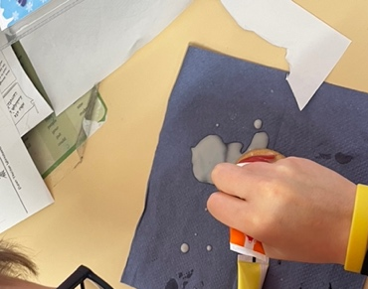
Dear Parents and Carers,
We have had a wonderful first term in Redwood class where we have embarked on a journey through one of the most significant periods in modern history: World War II.
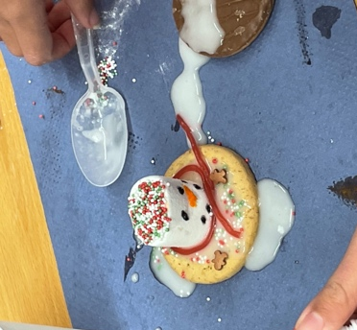
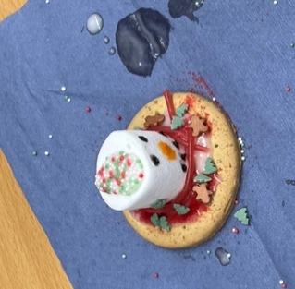
We explored the key events that shaped the war, the causes of the conflict and how countries around the world became involved. We tackled the complex themes of Alliances, Leadership, and Sacrifice, and we looked closely at the lives of ordinary people affected by the war, including children, soldiers, and those on the Home Front. We had an insightful visit to Mansfield Museum to bring our learning to life and got fully involved in an Evacuation Day. The children showed enthusiasm, thoughtful discussion and empathy throughout their learning.
Next term we will have a Science themed focus for our Enquiry topic and question. And will theme our English around the text, ‘The Last Bear,’ by Hannah Gold.
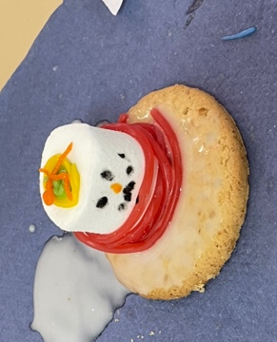
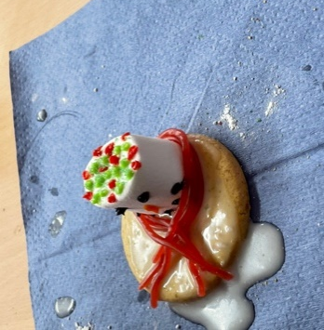
We want to take this opportunity thank you for your ongoing support, for your time volunteering to support with in school activities and dedication in helping the children with their learning at home. We would like to wish everyone a well-deserved Christmas break.
Since many children chose to enjoy the biscuits they wonderfully designed in school, we have included some pictures of them here!
See you next term,
Mrs Price and Mrs Nawaz

