BSFA Meeting Minutes
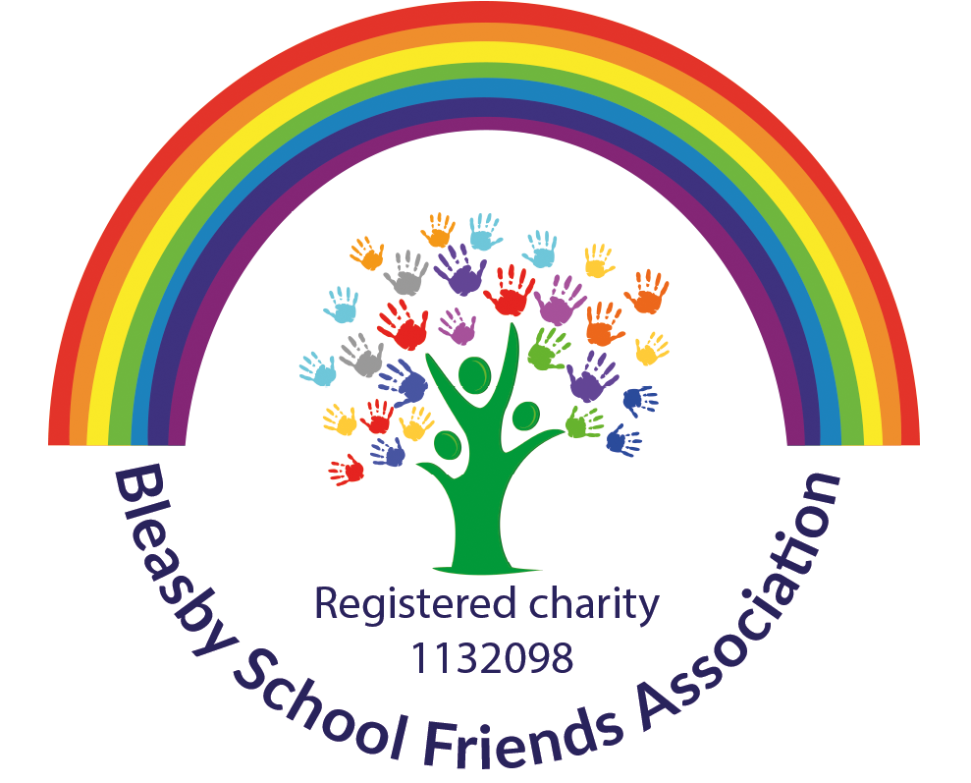

Attendees & Apologies

Nicky Blacknall
Rosie Raife
Laura Perkins
Kathy Smith
Jo West
Katherine Huxtable-Drake
Maxine Meaden
Emma Terry

Agenda Items
- Welcome & Apologies
- Finance update
- Administration
- Update on Spring term events
- AOB

Item | Discussion | Action Points
Welcome & Apologies | Apologies – Jane Day, Victoria Smallwood, Liena Mostyn and Claire Poyser-Blair.
Finance | Current balance £7216  Money out since last meeting £0  Money in since last meeting £470 (monster mash tickets)  Money still due out:  £300 approx (school Glockenspiels)  £800 approx (DART)  Money still due in:  £104 (xmas play refreshments)  147 (santas grotto tickets)  158 (xmas cards)  - Concerns were raised about missed funding opportunities (KHD) and wanting there to be more organisation and efficiency (LP) within the administration of events and paperwork. | JW  - RR to work with team to share responsibilities so we can work more effectively as a team.
Charities Commission | Difficulties RR and JW gaining access in order to amend the information – | KHD and RR to spend time together to try and sort this out.
2024 events | Discussion on events for 2024  - Spring movie night and /or break the rules. Would prefer to do break the rules on March 27^{th.} Waiting on confirmation from school.  - Cheese and Wine night in lieu of a curry night due to kitchen restrictions. KS & NB to lead on this. Date set was Saturday 27th April. School to finalise date so we can start promotion.  - Mothers and Others – would like to do tote bags but prep would need to start before half term. Also need to add costs to school money  - Bags for school – booked 28th February  - Fathers day – ideas discussed and tabled for next meeting  - Sports day events (including bouncathon) – waiting for confirmation on school timetable  - Ladies event – to be discussed at later meeting  - Summer party – to be discussed at later meeting | - Waiting for confirmation from school – NB  - Waiting on confirmation from school NB  - LP to investigate some free tote bags  - JW to send out a reminder week before half term
AOB | JW had been asked to raise the following:  - Boost fund (GB) – currently the BSFA are unable to accommodate this as it would involve an entire rewrite of the constitution which would be at a cost.  - Activall (LB) – Staff raised concerns about “policing” the use of this at school – suggested a discussion with Mrs Cast about whether it is something the school would like.  - Whats app buy and sell group (LB) – discussed and agreed that this would be fine but that the BSFA would not administrate or police the whats app group, donations would be on a honesty basis and a whats app group can be set up by anyone and the link shared.  - BSFA newsletter – agreed that once a term this might be a nice way to keep everyone updated with whats coming up and what has been achieved in the previous term etc, | JW to look into creating this (will liaise with VS)
Date of next meeting | 22nd February 2024 – venue TBC

Action Points

