The Monkey Book
The Monkey Book is a home-school record for your child. The work for the week is stuck on the right-hand side page. Important messages also appear in this section. Please encourage your child to talk about their day & what they have enjoyed at school. Speak to us if you have any queries or concerns. Please send your child to school with their Monkey Book every day.
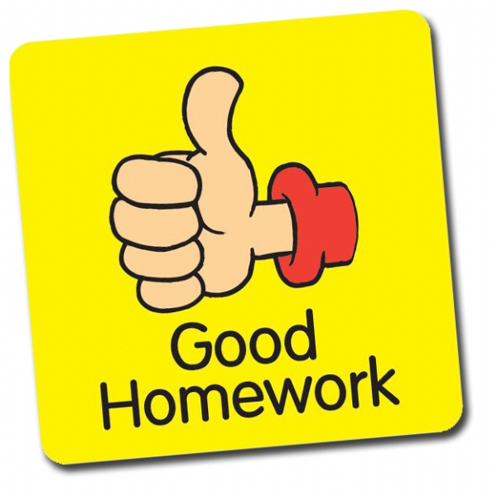
Reading
Please read with your child regularly (10-15 minutes most days if possible). When you hear your child read, please write the date on the left-hand side and add comments, using the following system to record each session:
✓✓ : my child read the book independently, with little or no help.
✓✓ : my child could read some of the words but needed help to maintain pace and flow.
✓ : this book was too difficult for my child to read alone, but I read it to my child, and we shared and discussed it.

Spellings & Times Tables are given out on a Friday in the red ‘Spellings’ book and tested the following Friday morning. Please set aside a little time to learn spellings and work on patterns every week. Year 3s will also have weekly times tables – please encourage regular revision at home.

Homework Each half term an Enquiry related homework task will be set via email and on the class page of the school website. There will also be suggestions for fun online learning in key subject areas on there.
WATER: Please bring a named plastic drinking bottle each day.
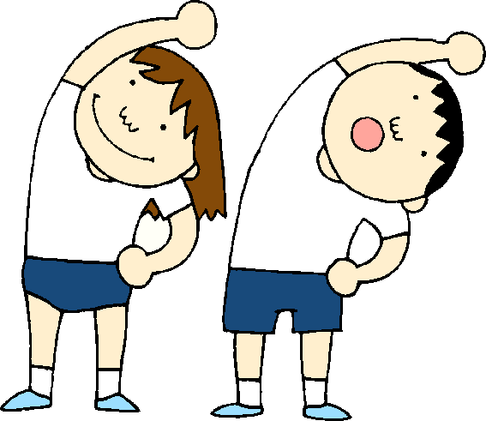 P.E. kit should be worn on Tuesdays & Thursdays.

Please make sure any pencil cases, stationery and toys are kept at home at all times. Thank you.

Finally, please make sure that all school uniform is NAMED!

THANK YOU. Mr Ryan

Autumn Term Learning: Coverage and Topics for the Autumn Term

Subject | Autumn Term 1st Half | Autumn Term 2nd Half
English Writing | Coverage of Y2 and Y23 curriculum using the texts Journey by Aaron Becker and The Bear and the Piano by David Litchfield. | Coverage of Y2 and Y3 curriculum. Emma Jane’s Aeroplane by Kate Haworth, The Jolly Christmas Postman and non-fiction texts linked to our British Explorer’s Enquiry.
English Guided Reading and Comprehension | Guided reading groups and comprehension activities in separate Year / Ability groups. | Guided reading groups and comprehension activities in separate Year / Ability groups.
Maths (to be taught in separate Year Groups) | Place value, Addition & Subtraction.  We will also have daily Mastering Number sessions. | Addition & Subtraction and Multiplication & Division A  We will also have daily Mastering Number sessions.
Science | There will be a focus on Scientific enquiry which makes particular links to Materials, Explorers’ contributions to science and Science’s contributions to exploration. | There will be a focus on Scientific enquiry which makes particular links to Materials, Explorers’ contributions to science and Science’s contributions to exploration.
RHSE | Me and my relationships | Valuing difference
History (Enquiry) | British Explorers To know about events beyond living memory that are significant nationally / globally. To know about the lives of significant individuals in the past who have contributed to national and international achievements. | To know how to use a timeline and words to express passing of time. To know how to use sources to learn about individuals from the past. To find similarities between the present and the past.
Geography | Using maps to learn routes and the locations of the places visited by famous British Explorers. | Use vocabulary to explore the climate and landscape features of these places.
Art / DT | Compare indigenous art from Australia with European painting styles of the same period. | Food and Nutrition: Designing a healthy packed lunch for an expedition. Designing, planning, making and evaluating a junk model boat for an explorer
RE | Myself and Caring for Others How do we show we care for others? Why does it matter? Christianity, Judaism. | Celebrations and Festivals  Who celebrates what and why? Christianity and Judaism
PE | Hockey and Dance | Tag Rugby and Gymnastics
Music | Charanga music program. | Christmas Production.
Computing | Purple Mash: E-Safety | Purple Mash: Grouping & Sorting and Pictograms.

