

Bleasby School Year 6 GPS

(Grammar, Punctuation
& Spelling)
Parent Guide 2023

This booklet is intended to help you in navigate your way through the terminology of the Key Stage 2 Grammar, Punctuation and Vocabulary Test, often referred to as GPS, so that you can support your child during this busy period of their life

The terminology of the GPS tests can often be a minefield for parents, who are often not familiar with the current curriculum in school. You may have overheard your child using phrases like fronted adverbials, relative clauses, subordinating conjunction is, the subject and object of the sentence, and wondered what does it all mean?

This booklet is intended as a guide to the terminology of the GPS test so that you, and your child, can use it as a revision reference in the build up to the KS2 SATs assessments. Throughout you will find explanations of the areas tested within the assessment with example questions too.

Each section in this booklet refers to one of the areas (or domains) tested in Grammar, Punctuation and Vocabulary Test. Read and discuss each section with your child and check that they understand the terminology. This terminology will be taught throughout Year 6 and should have previously been covered and taught in other year groups within the school.

The English Grammar, Punctuation and Vocabulary Test & Spelling assessment comprises of two papers. Paper 1 is the Grammar, Punctuation and Vocabulary Test and Paper 2 is a separate Spelling Test.

The grammar, punctuation and vocabulary test, seven different areas, as follows:

G1 – grammatical terms/word classes,
G2 – functions of sentences,
G3 – combining words, phrases and clauses,
G4 – Verb forms, tenses and consistency,
G5 – Punctuation,
G6 – Vocabulary &
G7 – Standard English and formality

G1: Grammatical Terms and Word Classes

Nouns

Nouns are naming words. You will need to know the different types of nouns and be able to spot them in a sentence. Use this table to help you identify different types of nouns:

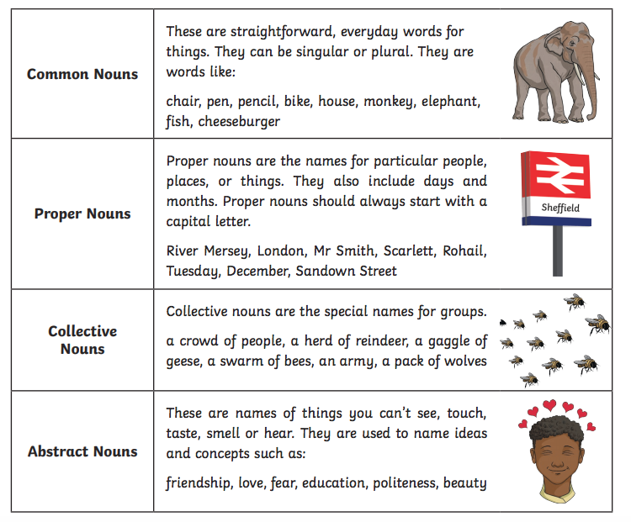

Verbs

Verbs are words that tell us what is happening in a sentence. They are often referred to as doing or being words. If the sentence doesn’t have a verb, it’s not a sentence. Here are some examples of verbs in sentences.

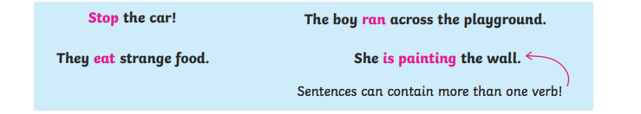

The Verb ‘To Be’

A tricky one for the children is ‘to be’ as they don’t always 5recognise it as a verb. That’s why it’s important that verbs are referred to as doing and being words. ‘To be’ is an irregular verb so use the table below to help you identify it in its different tense forms.

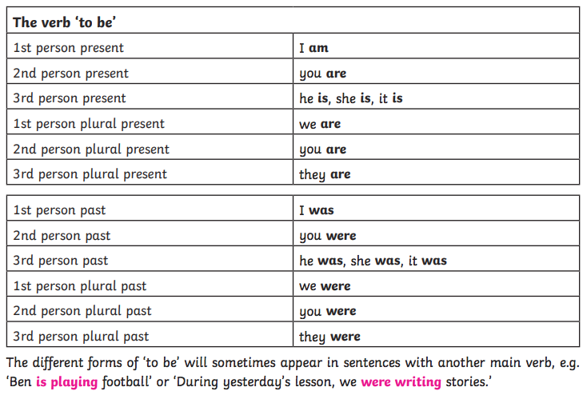

Adjectives

Objectives are words used to describe nouns.
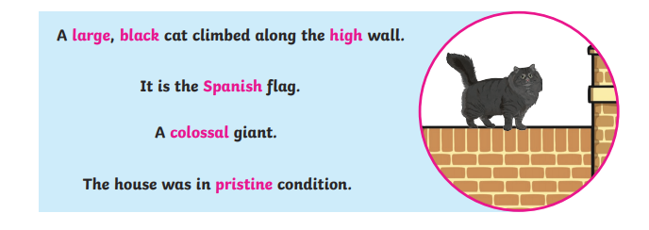
Adjectives can be used to describe: colour, size, shape, condition, age, personality, texture, feelings, appearance and origin/nationality.

Comparative and Superlative Adjectives

Adjectives can also be used to compare things. These are called ‘comparatives’. They can tell you if something is bigger, better, smarter and so on. You often add – er to make comparatives but sometimes the words ‘more’ or ‘less’ are used too.
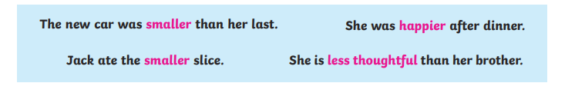

The ‘superlative’ is used to show something is the most, least, best or worst. Sometimes the words the most and the least are used to make the superlative.



Co-ordinating Conjunctions

Conjunctions are words used to join forces or sentences together. Firstly, children are taught coordinating conjunction is that are used to link to separate sentences together. They are often taught the acronym ‘FANBOYS’ to remember them: both part of the sentence (or main clauses) on either side of the conjunction would make sense on their own.

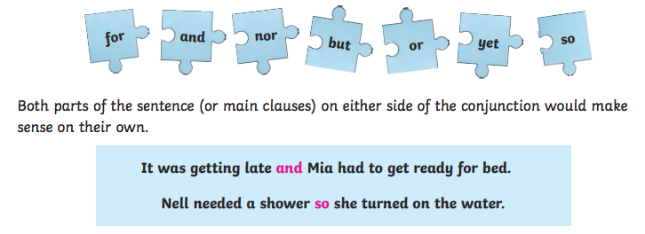

Subordinating Conjunctions

Subordinating conjunctions create complex sentences. Examples include:

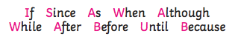

Subordinating conjunctions are used at the start of subordinate clauses.

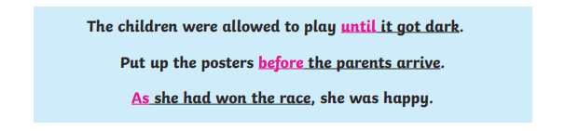

Subordinate clauses do not make sense on their own. They can appear at the beginning and at the end of sentence.

Pronouns

Pronouns are words that are used to replace a noun or a noun phrase. Without pronouns, spoken and written English would be very repetitive. For example:

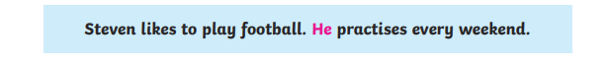

In the second sentence, the pronoun he refers to Steven. It has been used to avoid the repetition of using his name again. Please see below for a list of personal pronouns:

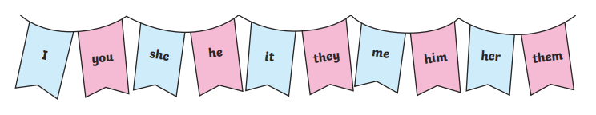

Possessive Pronouns

Possessive pronouns sure ownership or who something belongs to. They are: mine, yours, his, hers, its, ours, yours, theirs.



Relative Pronouns

Pronouns are: who, which, whose, where, when, and that. They are used to add further information about a noun in a sentence. For example:

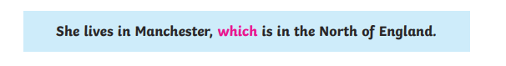
The relative pronoun above is used to start a relative clause (which is in the North of England) to give more information about the noun – in this case it’s harder giving the reader more information about Manchester.

Adverbs

Adverbs are words that usually give more information about the verb (they can sometimes describe another adverb or clause) explaining how, when, or why an action is taking place. Consider the following sentence:


If you had an adverb of manner, it gives more information about how the action in the sentence was done:



Adverbs can also be used to indicate the time, frequency or police of an action that takes place in writing. For example:

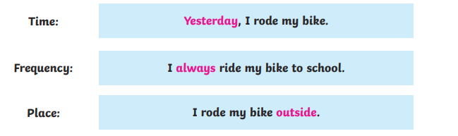

Adverbs of Possibility

Read the crystal balls below. The adverbs in each of the sentences are used to show how certain we are about something – these are called adverbs of possibility.

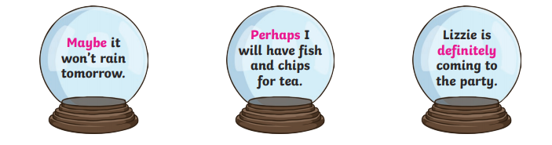

Adverbials

Adverbials are phrases (a small group of words) that function like an adverb. They usually express place (in the garden), when (early one morning) and how (like a flash of lightning) things happen. For example:

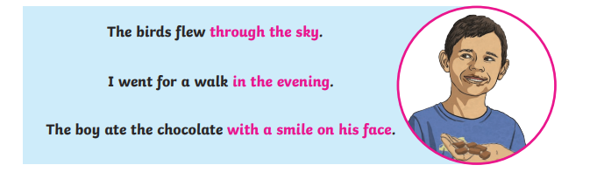

Fronted Adverbials

A fronted adverbial is a single word, phrase and or clause that comes at the front of the sentence (it comes before the verb or action it is describing). It is always separated from the main clause with a comma. For example:

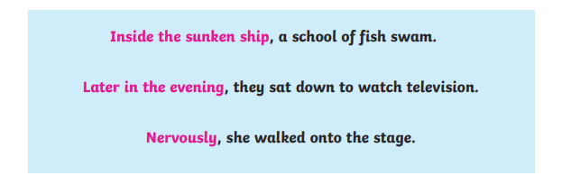

Prepositions

Prepositions are very commonly used words in the English language that explain where something is (beside, under, adjacent, inside), the direction something is moving (along, into, toward) or when something is happening (during, at 7am, on Monday).

By Year 6, children are expected to recognise a range of prepositions and know the difference between a preposition (used before a noun; for example; ‘I sat before the stage.’ And a subordinating conjunction (used to introduce a subordinate clause; for example: ‘I had to finish my homework before I went out to play.’

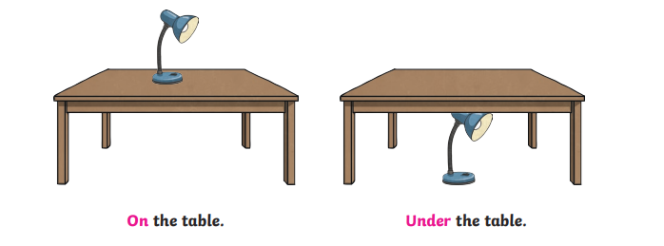

Determiners

A determiner is a word that introduces a noun such as a, an, every, three, many and those.

The determiner ‘the’ is known as the definite article and the determiners ‘a ‘and ‘and’ are known as the indefinite article. In the KS2 test framework, children are expected to use the forms of ‘a’ or ‘an’ according to whether the next word begins with the consonant or vowel. For example:
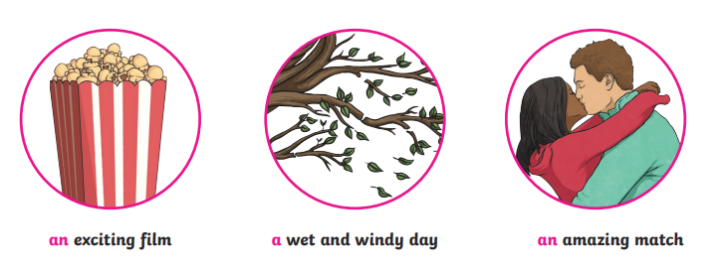

Subject and Object

In an active sentence, the subject is the noun (person, animal or thing) that is doing the verb (action). All sentences have a subject. For example:
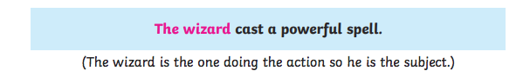

The object is a noun (person, animal or thing) that is having the verb (action) done to it, for example:


Not all sentences have an object. For example:
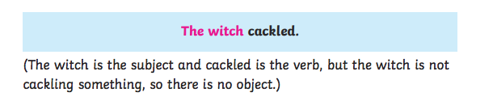

This is different in passive sentences.

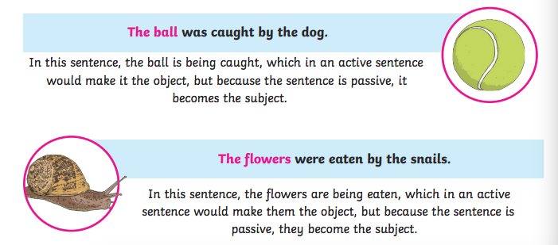

G2: Functions of Sentences

What is a Sentence?

A sentence has a capital letter at the beginning and ends with a full stop (.), question mark (?) or an exclamation mark (!). It must have a verb in it and it must make complete, grammatical sense on its own.

There are 4 different types of sentences, which are:
Statements,
Questions,
Commands &
Exclamations.

This section will help you to identify the different sentence types.

Statements

A statement is simply a sentence that tells you something. They usually end with a full stop (.). For example:



A statement can contain conjunctions and several clauses (often called in multi–clause sentence) so long as it still makes sense and finishes with you. (.):

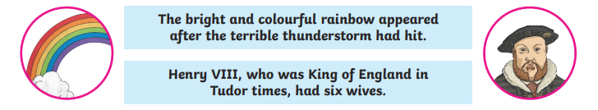

Questions

A question sentence asks a question – it is the sentence used to find out information. They always finish with a question mark (?) And often start with an interrogative word such as why, how, who, what and which.

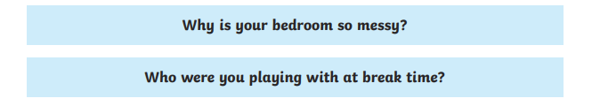

Some questions don’t start with an interrogative word and have a question tag at the end of the sentence.

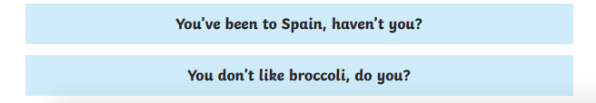

Commands

Commands are sentences that tell you to do something. They are found in instructions but they can also be urgent, angry and very short. A command candle can end with a. (.) or sometimes an exclamation mark (!). They always contain imperative (bossy) verbs.

All these sentences are commands. They are all telling someone what to do. The first one doesn’t sound as commanding as the others but it is still a command.

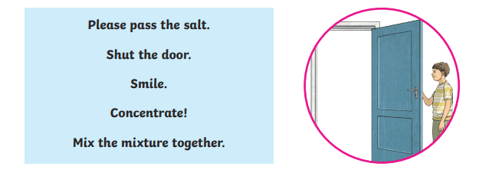
Exclamations

Exclamations start with and with the interrogative words ‘what’ or ‘how’, and always contain a subject and a verb.

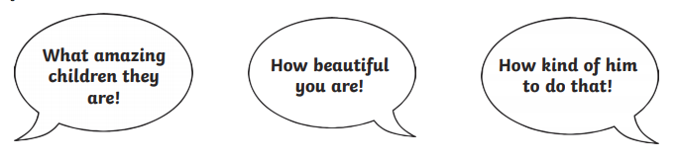

Exclamation sentences should not be confused with using an exclamation mark for punctuation to show a heightened emotion (fear, surprise, shock, etc.).

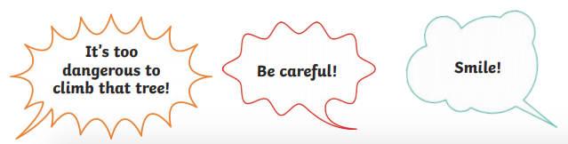

G3: Combining Words, Phrases and Clauses

It is important that children are able to identify different phrases and clauses in a sentence and what their functions are.

Sentences and Clauses

A sentence is a group of words that gives a complete thought or idea. The sentence must contain a verb and a subject. From KS1, children are taught to write sentences made up of more than one clause.

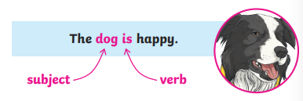

A clause is a group of words that contains a subject and a verb. Main (Independent) clauses can be a sentence themselves, such as ‘she ran’. In the sentence below, the two main clauses have been joined together using the conjunction ‘and’. These are often called ‘compound sentences’.

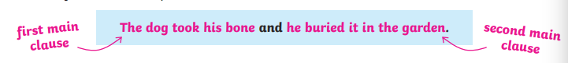

Relative Clauses

A relative clause begins with a relative pronoun. Relative pronouns are: who, whose, which, where, when and that. They are used to start in relative clause, which give extra information about a noun or pronoun in the sentence. They are usually demarcated using a comma (except when that is used). For example:

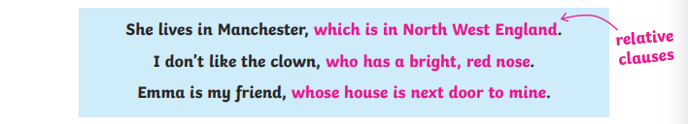

A relative clause can also be embedded in a sentence. It is then separated from the rest of the sentence by commas. For example:

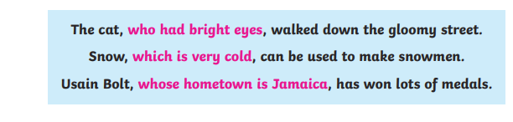

Noun Phrases

A noun phrase is part of the sentence that includes a noun – a person, place or thing – and the words, which describe it. For example, we might find the word cat in the sentence, which is a noun. However, by adding modifiers to the noun we can gather more information about it or distinguish which cat we are talking about, such as:

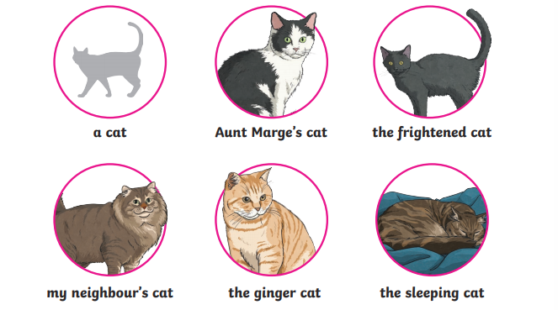

All the noun phrases above refer to cat but give more information about the specific cat being discussed in each sentence.

In KS2, children are taught to extend their noun phrases further by adding a further prepositional phrase, for example:

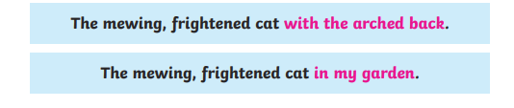
Subordinating Conjunctions

The subordinate conjunction is used to introduce a subordinate clause (see below) in complex (or multi-clause) sentences. Below you will see some of the main subordinate conjunctions that your child may be encouraged to use.

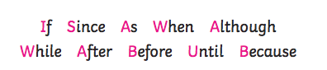

Subordinate Clauses

The subordinate clause – begins with a subordinate conjunction or a relative pronoun and contains both a subject and a verb. They do not make sense on their own; therefore, it is dependent on the main clause of the sentence in order for it to make sense.

Look at the following subordinate clauses; on their own they do not make sense:

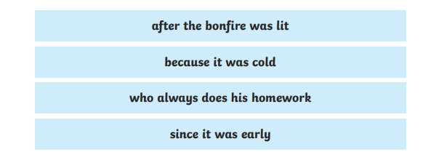
They only make sense when we add a main clause to each subordinate clause:
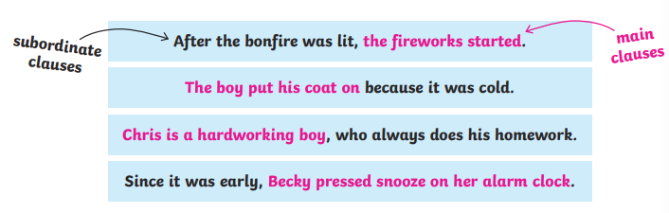

Remember: is subordinate clause cannot stand alone as a sentence because it does not make sense. The reader is left wondering, ‘where is the rest of the sentence?
G4: Verb Forms, Tense and Consistency

Verb tenses tell us when an action takes place, i.e. in the past, present or future. From KS1 pupils are taught to identify different tenses and change the tense of verbs, such as present tense to past tense. In their writing the must demonstrate that they can write consistently in the correct tense.

Simple Present and Simple Past Tense

The simple present tense of a verb is made by using the base form of a verb (the simplest form of the verb without any suffixes added), such as:

Or by adding an –s (or an –es) in third person (to write about another person):



We use the simple present tense to talk about:
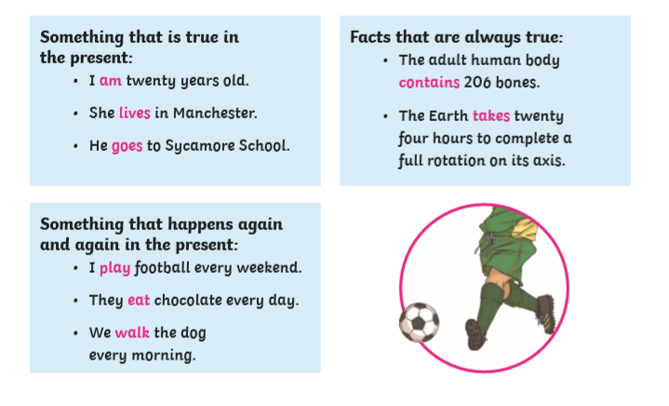

The simple past tense is used to talk about a completed action in the past. The main way to change a verb to past tense is to add the suffix –ed. However, there are many words where the spelling changes when the suffix –ed us added (such as ‘tidied’) and many irregular past simple tense verb forms, which children have to learn as they encounter them (such as ‘buy’ changing to ‘bought’).

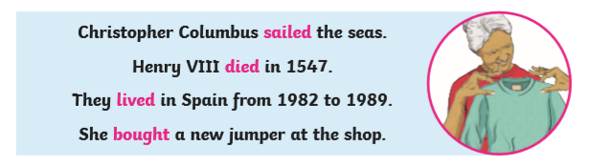

Verbs in the Perfect Form.

The present perfect tense is formed when you use the present tense of the verb ‘to have’ and the past participle of a verb. The is used to describe something that started in the past and continues now, or for things done several times in the past and continue to do so. For example:

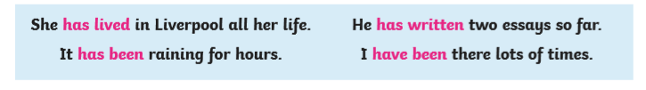

The past perfect tense is used to show an event that happened before another event in the past. It uses the past tense form of the verb ‘had’ and the past participle of a verb. For example:

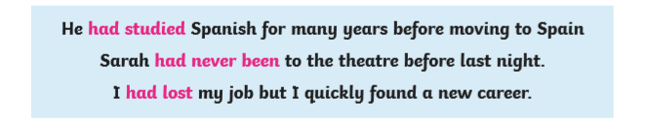

Modal Verbs

Modal verbs are sometimes also known as ‘auxiliary verbs’. They are used with other verbs to describe how likely things are to happen or to what degree something is known. Modal verbs include: can, could, may, might, will, would, must, should, ought to. For example:



Present and Past Progressive

Both the present progressive and past progressive are formed using the verb ‘to be’ and then, by adding the suffix ‘-ing’ to another verb. For example:



The present progressive is when the verb ‘to be’ is used in the present tense with another verb ending in ‘ing. It shows something that is currently taking place. The table below shows all of the present tense forms of the verb ‘to be’.

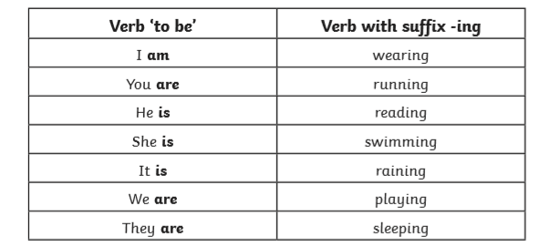

The past progressive is made when we use the simple past form of the verb ‘to be’ with a verb ending in –ing. It shows something that was happening and ongoing at some point in the past. For example:

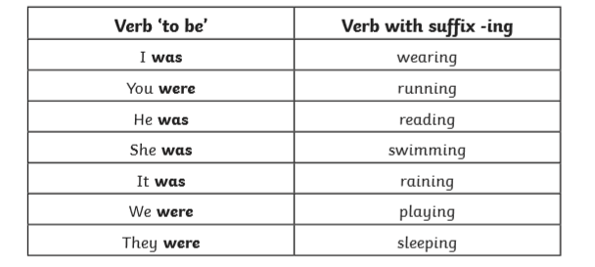

Tense Consistency is important throughout a piece of writing.

Subjunctive Verb Forms

The subjunctive verb form is used to express things that could or should happen. It can be used for:

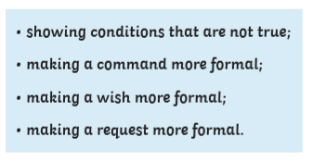

When describing conditions that are not true, we use ‘were’ instead of was, which creates a more formal sentence.

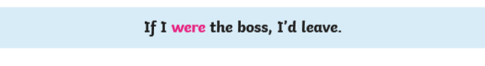
‘Had’ can also be used to create the subjunctive mood in sentences that show conditions that are not true.



For commands, wishes and requests using the subjunctive verb form makes it sound more formal. In these instances, the infinitive form of the verb ‘to be’ is replaced with just ‘be’.



Passive and Active

In most sentences, the subject of the sentence performs the action. For example:

The subject of the sentence is ‘the dog’ and the verb is ‘was chasing’. Because the subject is doing the action, the verb is said to be active.

We could swap the sentence around so that the cat becomes the subject.


When the subject (the cat) has something done to it (was chased) by someone or something else in the sentence, we call this a passive sentence.

Further examples of the passive voice being used are:


G5: Punctuation

Children are taught to use punctuation correctly within their writing. The following table will help you to understand all of the punctuation conventions taught throughout the primary stage:

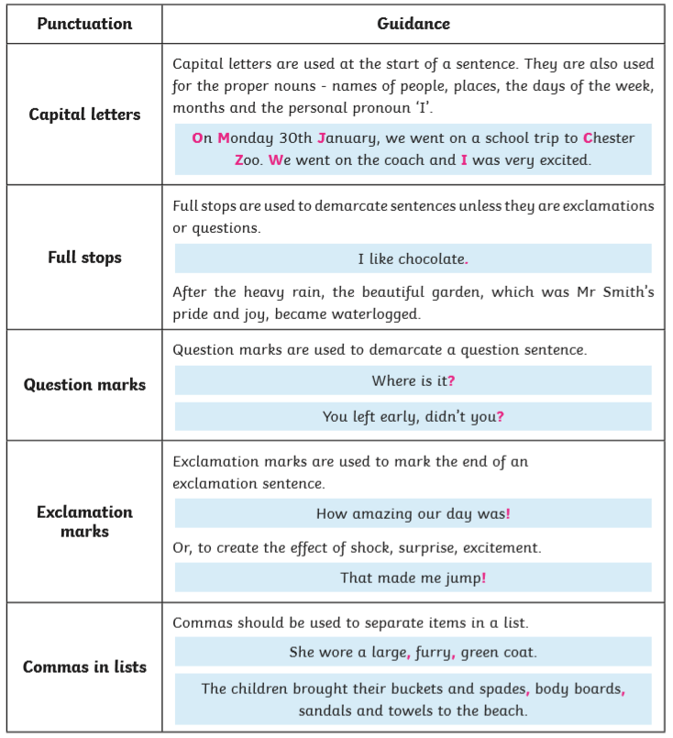

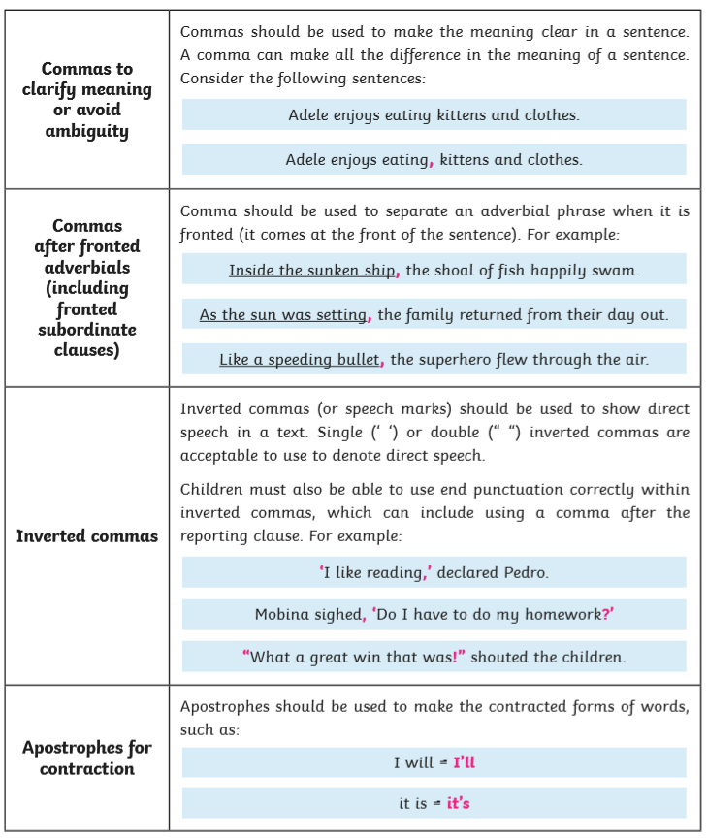

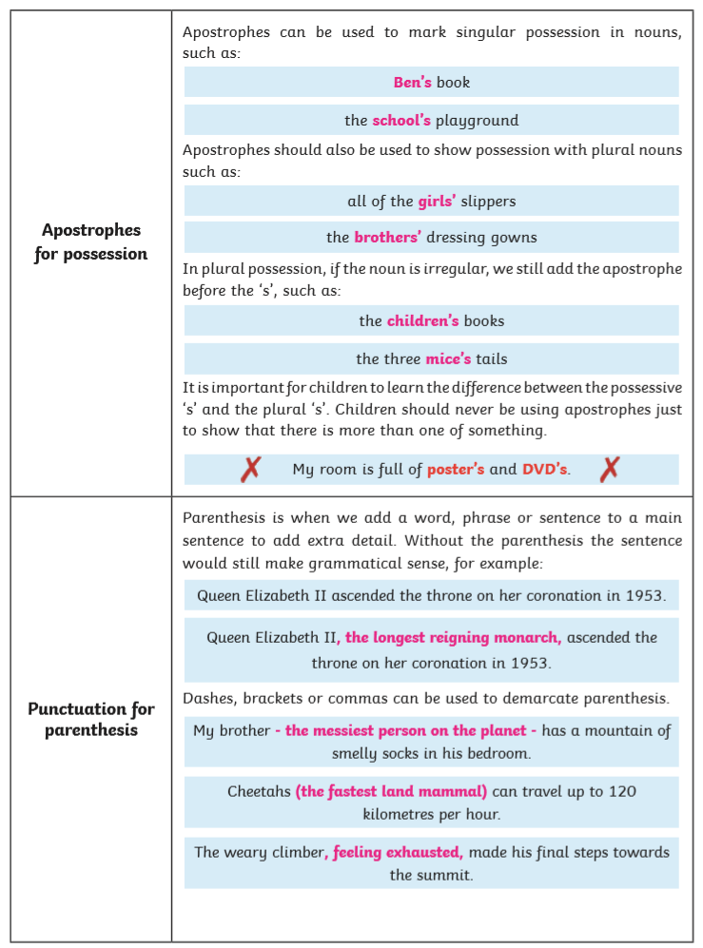

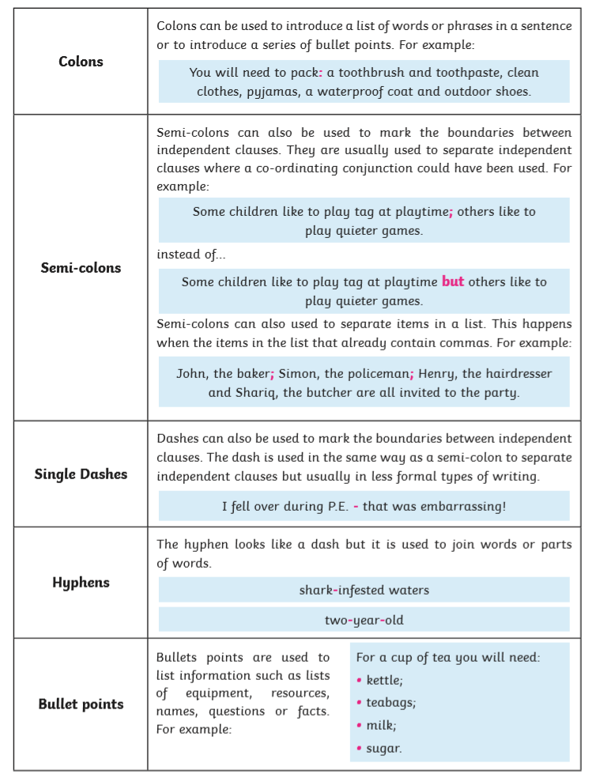

G6: Vocabulary

Synonyms and Antonyms

A synonym is a word or phrase that means exactly (or nearly the same) as another word or phrase. For example, synonyms of ‘cold’ (as in temperature) are: chilly, freezing and cool.

In KS2 children are encouraged to use more ambitious synonyms in their writing to improve their vocabulary and avoid repetition of the same words over and over again. For instance, consider the sentence below:

The word ‘scary’ in this sentence can be replaced with a wide range of synonyms such as: haunting, terrifying, horrifying, eerie, spooky, sinister etc.

It could also be extended by adding more than one synonym to create a more ambitious noun phrase.

Antonyms are words which have the opposite meanings. For example:

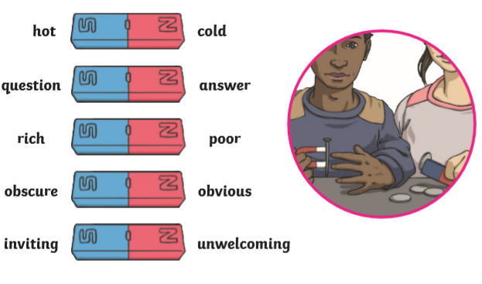

Prefixes

A prefix is a group of letters added to the beginning of a word to change its meaning. Learning prefixes helps children develop their spelling and vocabulary. The following prefixes (and more) are taught throughout KS1 and KS2:

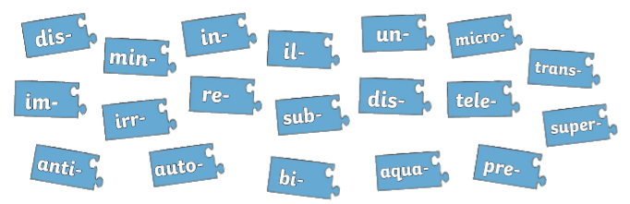
Suffixes
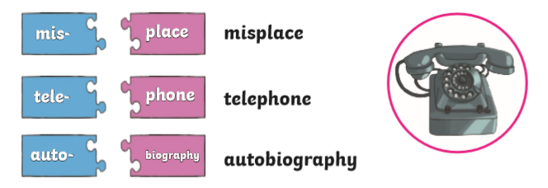

A suffix is a string of letters that are added to a root word, which change or add to its meaning. Suffixes can also be used to change a word to an adjective, a verb, or an adverb. This table shows the stage when it is introduced to pupils within the school.
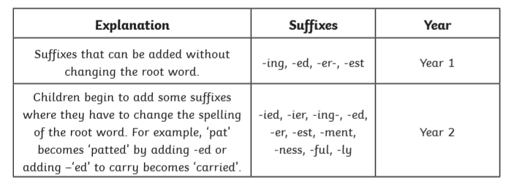
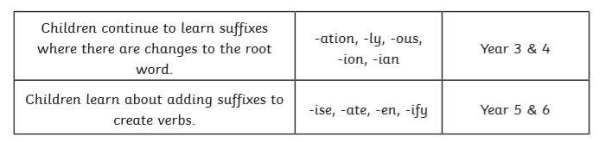

Word Families

Word families are groups of words that have the same root word or common feature or pattern. The root word may be changed by adding prefixes and suffixes.

For instance, included in the word family for ‘real’, we find words such as: reality, realise, unrealistic and really.

G7: Standard English and Formality

It is important that children can recognise words and phrases that are ‘Standard English’ and the differences between formal and informal language in writing.

Standard English

Standard English is accepted as the ‘correct’ form of English used in speaking and writing. Standard English follows grammatical rules such as, the correct use of verb tenses or pronouns. Below are examples of Standard and Non-Standard English.

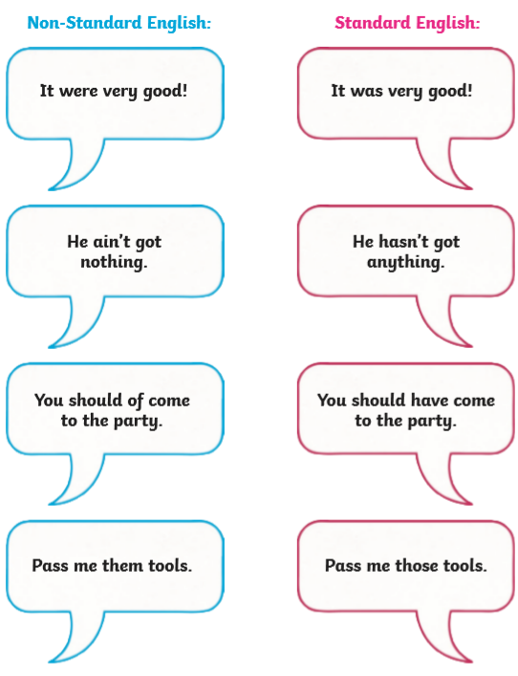

Formal and Informal Vocabulary

There are situations when people are expected or required to speak (or write) using a more formal style of language.

Formal language is more official and serious, and the correct grammar should always be used.

Informal language uses a more relaxed and casual style. Slang words and abbreviations are more accepted in informal speech.

