Our Summer Term enquiry focus will focus on **Science**: We will be learning all about: mental and physical wellbeing, healthy eating, the human body and the digestive system. We will have close links to our enquiry in English, PE and other foundation subjects.

Big Question: What is a healthy lifestyle? What could I do to be healthier?

Other Subjects:

|  |  |
| --- | --- |
| English | We will study a range of texts around the topic enquiry. How To Live Forever, The Tear Thief, Our Tower And Apes to Zebras A-Z of Shape and Poems. We will be writing letters, character descriptions, instructions, poems, diaries, newspaper reports and fantasy writing. |
| Maths | We follow the White Rose Maths Scheme. This term’s units are on Decimals, Time, Money, Shapes, Statistics and Position and Direction. |
| R.E. | This term we begin with a focus on Understanding Christianity. We will find out about the Kingdom of God, including Pentecost. |
| Science | States of Matter & Animals including humans (Enquiry Focus) |
| RSHE | Being My Best & Growing and Changing |
| P.E. | Tennis, Cricket and Athletics |
| Computing | This term we cover: computing shortcuts, hardware investigators and game creators. |
| Art and DT | We will cover a range of skills with a focus on creating sculptures. In DT we will learn to create healthy food and drink. |
| Music | Our work will focus on composition and digital music. |
| French | Learning key vocabulary for conversation with Mrs Frost. |

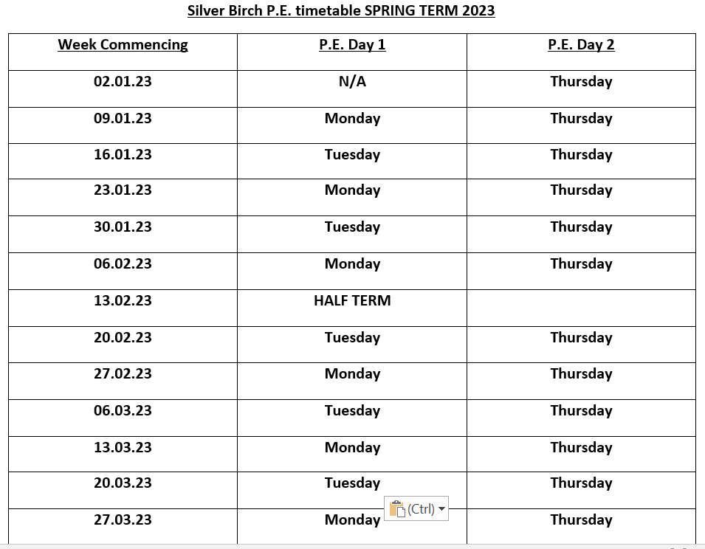See the table below for PE days. Please ensure children bring their kit to school on the Monday of each week and take them home on the Friday of each week.

|  |
| --- |
| **P.E. Day 2** |
| **N/A** |
| **Friday** |
| **Friday** |
| **Friday** |
| **Friday** |
| **Friday** |
| **Half Term** |
| **Friday** |
| **Friday** |
| **Friday** |
| **Friday** |
| **Friday** |
| **Friday** |