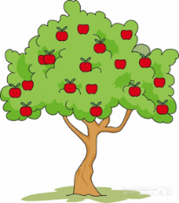 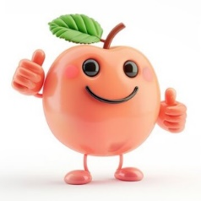

Our Spring Term enquiry focus throughout school is SCIENCE. Our Big Question is: Do animals and humans need the same things to stay happy and healthy? Pips may experience some of this learning throughout the term, depending on the sessions they attend.

Pips focussed learning this half term:

|  |  |  |  |  |
| --- | --- | --- | --- | --- |
| Phonics | Literacy | Maths | P.E | Wild Wednesday |
| Phase 1 phonics – body percussion | Listen to and talk about stories.  Play rhyming games.  Practise forming letters and recognising those letters in our name. Recognise and write our name. | Pattern – looking for patterns all around us. Comparing big and small. | This will be on a Monday afternoon. Please come to school wearing P.E kit (Navy blue tracksuit or leggings, white t-shirt, trainers).  Fun and games. | This will take place every Wednesday afternoon. Please send waterproof trousers, coat and welly boots in a named bag to stay at school if your child attends school on a Wednesday. |